**Comparison of CNN and Contour Algorithm for**

**Deaf Language Identification Using Hand Gesture Recognition**

A Project Work-II Report

Submitted in partial fulfillment of requirement of the

Degree of

**BACHELOR OF TECHNOLOGY   
in   
COMPUTER SCIENCE AND ENGINEERING**

BY

**Adarsh Pathak (EN17CS301017)**

**Faraz Ahmed Khan (EN17EL301049)**

Under the Guidance of

**Mr. Chandrashekhar Kothari**



**Department of Computer Science and Engineering**

**Faculty of Engineering**

**MEDI-CAPS UNIVERSITY, INDORE- 453331**

**Jan-May 2021**

**Report Approval**

The project work **“Comparison of CNN and Contour Algorithm for Deaf Language Identification Using Hand Gesture Recognition”** is hereby approved as a creditable study of an engineering/computer application subject carried out and presented in a manner satisfactory to warrant its acceptance as prerequisite for the Degree for which it has been submitted.

It is to be understood that by this approval the undersigned do not endorse or approved any statement made, opinion expressed, or conclusion drawn there in; but approve the “Project Report” only for the purpose for which it has been submitted.

Internal Examiner

Name:

Designation:

Affiliation:

External Examiner

Name:

Designation:

Affiliation:

**Declaration**

I/We hereby declare that the project entitled **“Comparison of CNN and Contour Algorithm for Deaf Language Identification Using Hand Gesture Recognition”** submitted in partial fulfillment for the award of the degree of Bachelor of Technology in Computer Science Department completed under the supervision of **Mr. Chandrashekhar Kothari, Assistant Professor in Computer Science Department,** Faculty of Engineering, Medi-Caps University Indore is an authentic work.

Further, I/we declare that the content of this Project work, in full or in parts, have neither been taken from any other source nor have been submitted to any other Institute or University for the award of any degree or diploma.

**Signature and name of the student(s) with date**

**Certificate**

I, **Mr. Chandrashekhar Kothari** certify that the project entitled **“Comparison of CNN and Contour Algorithm for Deaf Language Identification Using Hand Gesture Recognition”** submitted in partial fulfillment for the award of the degree of Bachelor of Technology by **Adarsh Pathak (EN17CS301017), Faraz Ahmed Khan (EN17EL301049)** is the record carried out by him/them under my/our guidance and that the work has not formed the basis of award of any other degree elsewhere.

________________________________

Mr. Chandrashekhar Kothari

Computer Science and Engineering

Medi-Caps University, Indore

________________________________

<Name of External Guide (If any)>

<Name of the Department>

Name of the Organization

_____________________

Dr. Suresh Jain

Head of the Department

Computer Science and Engineering

Medi-Caps University, Indore

**Acknowledgements**

I would like to express my deepest gratitude to Honorable Chancellor, **Shri R C Mittal,** who has provided me with every facility to successfully carry out this project, and my profound indebtedness to **Prof. (Dr.) Sunil K Somani,** Vice Chancellor, Medi-Caps University, whose unfailing support and enthusiasm has always boosted up my morale. I also thank **Prof. (Dr.) D K Panda,** Dean, Faculty of Engineering, Medi-Caps University, for giving me a chance to work on this project. I would also like to thank my Head of the Department **Prof. (Dr.) Suresh Jain** for his continuous encouragement for betterment of the project.

I express my heartfelt gratitude to my **Project Guide, Mr. Chandrashekhar Kothari and Project Coordinators, Dr. Kailash Chandra Bandhu and Mr. Abhishek Sable** for their support and guidance.

It is their help and support, due to which we became able to complete the design and technical report.

Without their support this report would not have been possible.

**Adarsh Pathak (EN17CS301017)**

**Faraz Ahmed Khan (EN17EL301049)**

B.Tech. IV Year

Department of Computer Science

Faculty of Engineering

Medi-Caps University, Indore

**ABSTRACT**

Inability to speak is considered to be true disability. People with this disability use different modes to communicate with others, there are number of methods available for their communication one such common method of communication is sign language.

Developing sign language application for deaf people can be very important, as they’ll be able to communicate easily with even those who don’t understand sign language. Our project aims at taking the basic step in bridging the communication gap between normal people, deaf and dumb people using sign language.

The main focus of this work is to create a vision-based system to identify sign language gestures from real time image capturing. The reason for choosing a system based on vision relates to the fact that it provides a simpler and more intuitive way of communication between a human and a computer. In our project, we have developed 3 modules which involves 49 different gestures overall which can be predicted.

This project compares the performance of two methods for hand gesture recognition for number identification and also predicts characters, common words and numbers through CNN.

To train the classification model we have used CNN (Convolution Neural Network) which is a part of deep learning approach. CNN model was trained using the images from the dataset that was created by our team. Trained CNN model was used to make predictions by taking real time images from end user. The contour algorithm creates the boundary of the hand and predict the number using the convexity hull defects algorithm and gives the output in the frame. The proposed methods of CNN and Contour achieved the accuracy of 91.2% and 93.8% respectively.

The data set used consists of American Sign Language (ASL) and some custom Gestures, with around 6000 images belonging to 49 gestures categories within three (A-Z, Numbers, Commonly used words).

**Table of Contents**

|  |  |  |
| --- | --- | --- |
| **Chapter No.** | **Content** | **Page No.** |
|  | Report Approval | ii |
| Declaration | iii |
| Certificate | iv |
| Acknowledgement | v |
| Abstract | vi |
| Table of Contents | vii |
| Abbreviations | ix |
| List of Figures | x |
| Chapter 1 | Introduction | 1-3 |
| 1.1 Introduction | 1 |
| 1.2 Sign Language Overview | 1 |
| 1.3 Objectives | 3 |
| 1.4 Scope of Improvement | 3 |
| Chapter 2 | System Requirement Analysis | 4 |
| 2.1 Software Requirement | 4 |
| 2.2 Hardware Requirement | 4 |
| Chapter 3 | System Design | 5-7 |
| 3.1 System Architecture | 5 |
| 3.2 Use Case Diagram | 6 |
| 3.3 Activity Diagram | 7 |
| Chapter 4 | CNN (Convolution Neural Network) | 8-14 |
| 4.1 What Are Convolutional Neural Networks? | 8 |
| 4.2 How Do Convolutional Neural Networks Work? | 8 |
| 4.3 **Convolution of An Image** | 10 |
| 4.4 **Relu Layer** | 12 |
| 4.5 Pooling Layer | 13 |
| 4.6 Stacking Up the Layers | 14 |
| Chapter 5 | Contour | 17-18 |
| 5.1 What is Contour? | 17 |
| 5.2 Convex Hull | 17 |
| 5.3 Convexity Defects | 18 |
| Chapter 6 | Testing | 20-24 |
| 6.1 Unit Testing | 20 |
| 6.2 Integration Testing | 20 |
| 6.3 Test Cases | 21 |
| 6.4 Application’s UI | 22 |
| 6.4.1 Predict A-Z Window | 22 |
| 6.4.2 Predict Number Window | 23 |
| 6.4.3 Predict Common words Window | 24 |
| Chapter 7 | Results and Analysis | 25-35 |

|  |  |  |
| --- | --- | --- |
|  | 7.1 Prediction of A-Z (Alphabets) | 25 |
| 7.2.1 Prediction of 1-5 (Numbers) By CNN | 26 |
| 7.2.2 Prediction of 1-5 (Numbers) By Contour | 28 |
| 7.3 Prediction of Common Words | 30 |
| 7.4Dataset Used | 32 |
| 7.5 Accuracy | 35 |
| Chapter 8 | Limitations and Future Scope | 38 |
|  | 8.1 Limitations | 38 |
| 8.2 Future Scope | 38 |
| Chapter 9 | Conclusion | 39 |
|  | References | 40 |
| Appendix | 41 |
| List of Publications | 47 |

**Abbreviations**

|  |  |
| --- | --- |
| **ASL** | American Sign Language |
| **CNN** | Convolution Neural Network |
| **ReLU** | Rectified Linear Unit |
| **GUI** | Graphical User Interface |
| **ETA** | Estimated Time of Arrival |
| **ROI** | Region of Interest |

**List of Figures**

|  |  |  |
| --- | --- | --- |
| **Figure No.** | **Figure Name** | **Page No.** |
| 1.1 | American Standard Sign Language | 2 |
| 3.1 | System Architecture | 5 |
| 3.2 | Use Case Diagram | 6 |
| 3.3 | Activity Diagram | 7 |
| 5.1 | Contour Boundary of the Hand | 17 |
| 5.2 | Convex hull Boundary (Red) of Hand | 18 |
| 5.3 | Convexity defects of hand gesture at run time | 18 |
| 5.4 | Process Flow of Contour Algorithm | 19 |
| 6.1 | Application UI | 22 |
| 6.2 | A-Z UI | 22 |
| 6.3 | Number UI | 23 |
| 6.4 | CNN and Contour UI for Numbers | 23 |
| 6.5 | Common Words UI | 24 |

CHAPTER-1

INTRODUCTION

1.1 INTRODUCTION

Motion of any body part like face, hand is a form of gesture. Here for gesture recognition, we are using image processing and computer vision. Gesture recognition enables computer to understand human actions and also acts as an interpreter between computer and human. This could provide potential to human to interact naturally with the computers without any physical contact of the mechanical devices. Gestures are performed by deaf and dumb community to perform sign language. This community used sign language for their communication when broadcasting audio is impossible, or typing and writing is difficult, but there is the vision possibility. At that time sign language is the only way for exchanging information between people. Normally sign language is used by everyone when they do not want to speak, but this is the only way of communication for deaf and dumb community.

Some of the major problems faced by a person who are unable to speak is they cannot express their emotion as freely in this world. They are not able to utilize (Artificial Intelligence/personal Butler) like google assistance, or Apple's SIRI etc. One of the solutions to talk with the deaf-mute people is by using the mechanisms of sign language.

Hand gesture is one of the methods used in sign language for non-verbal communication. Given a hand gesture, implementing such an application which detects predefined American sign language (ASL) in a real time through hand gestures and display it on screen.

1.2 SIGN LANGUAGE OVERVIEW

Deaf people around the world communicate using sign language as distinct from spoken language in their everyday a visual language that uses a system of manual, facial and body movements as the means of communication. Sign language is not an universal language, and different sign languages are used in different countries, like the many spoken languages all over the world. Some countries such as Belgium, the UK, the USA or India may have more than one sign language. Hundreds of sign languages are in used around the world, for instance, Japanese Sign Language, British Sign Language (BSL), Spanish Sign Language, Turkish Sign Language.

Sign language is a visual language and consists of 3 major components: 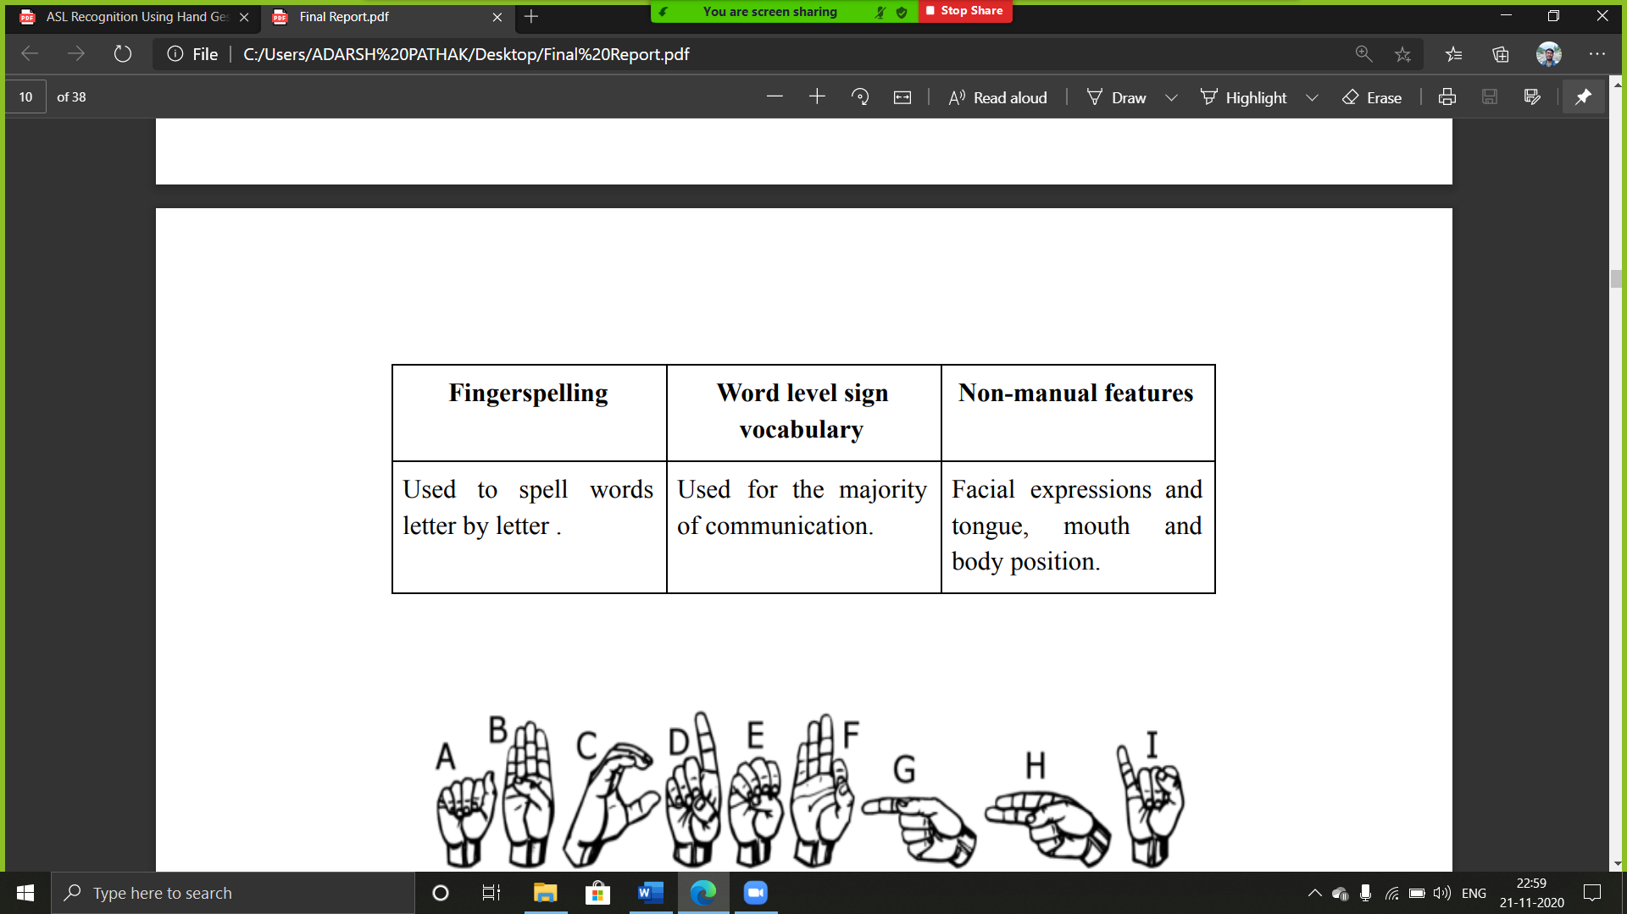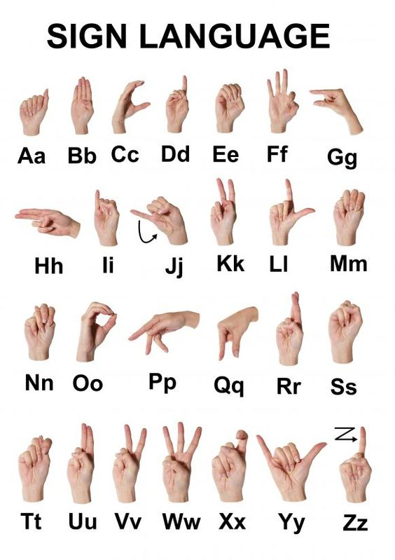

Figure 1.1: American Standard Sign Language

**1.3. OBJECTIVES**

The aims of this project are as follows:

* User-friendly based GUI built using industrial standard Tkinter.
* Comparing real time number detection based on gesture made by user by Contour and CNN algorithms.
* Real time American standard character detection based on gesture made by user.
* Real time commonly used words detection based on gesture made by user.
* Real time number detection based on gesture made by user.

Our strategy involves implementing such an application which detects pre-defined American sign language (ASL) through hand gestures. For the detection of movement of gesture, we would use basic level of hardware component like camera and interfacing is required. Our application would be a comprehensive User-friendly Based system built on Tkinter module.

This application will comprise of three core modules, one is that simply detects Alphabets, Number, Commonly Used Words. The second will collect the data and create the folder if it doesn’t exist. Third module will train the model on collected data and save the progress into json.

**1.4 SCOPE OF IMPROVEMENT**

* This project is working on image currently, further development can lead to detecting the motion of video sequence and assigning it to a meaningful sentence with TTS assistance.
* Future research can be done with possible improvement such as more refined data and more accurate CNN model.
* The adaptiveness of image capturing in different environments can be improved.

CHAPTER-2

SYSTEM REQUIREMENTS

**2.1 HARDWARE REQUIREMENTS**

* Intel Core i3 3rd gen processor or later.
* 1024 MB disk space.
* 4 GB RAM.
* Any external or inbuild camera with minimum pixel resolution 200 x 200 (300ppi or 150lpi) 4-megapixel cameras and up.

**2.2 SOFTWARE REQUIREMENTS**

* Microsoft Windows XP or later / Ubuntu 12.0 LTS or later /MAC OS 10.1 or later.
* Python Interpreter (3.7).
* Spyder 3.8
* TensorFlow framework (2.2 or higher), Keras API.
* Tkinter module.
* Python OpenCV2, scipy, sys, keyboard.

CHAPTER-3

**SYSTEM DESIGN**

3.1 **SYSTEM ARCHITECTURE**

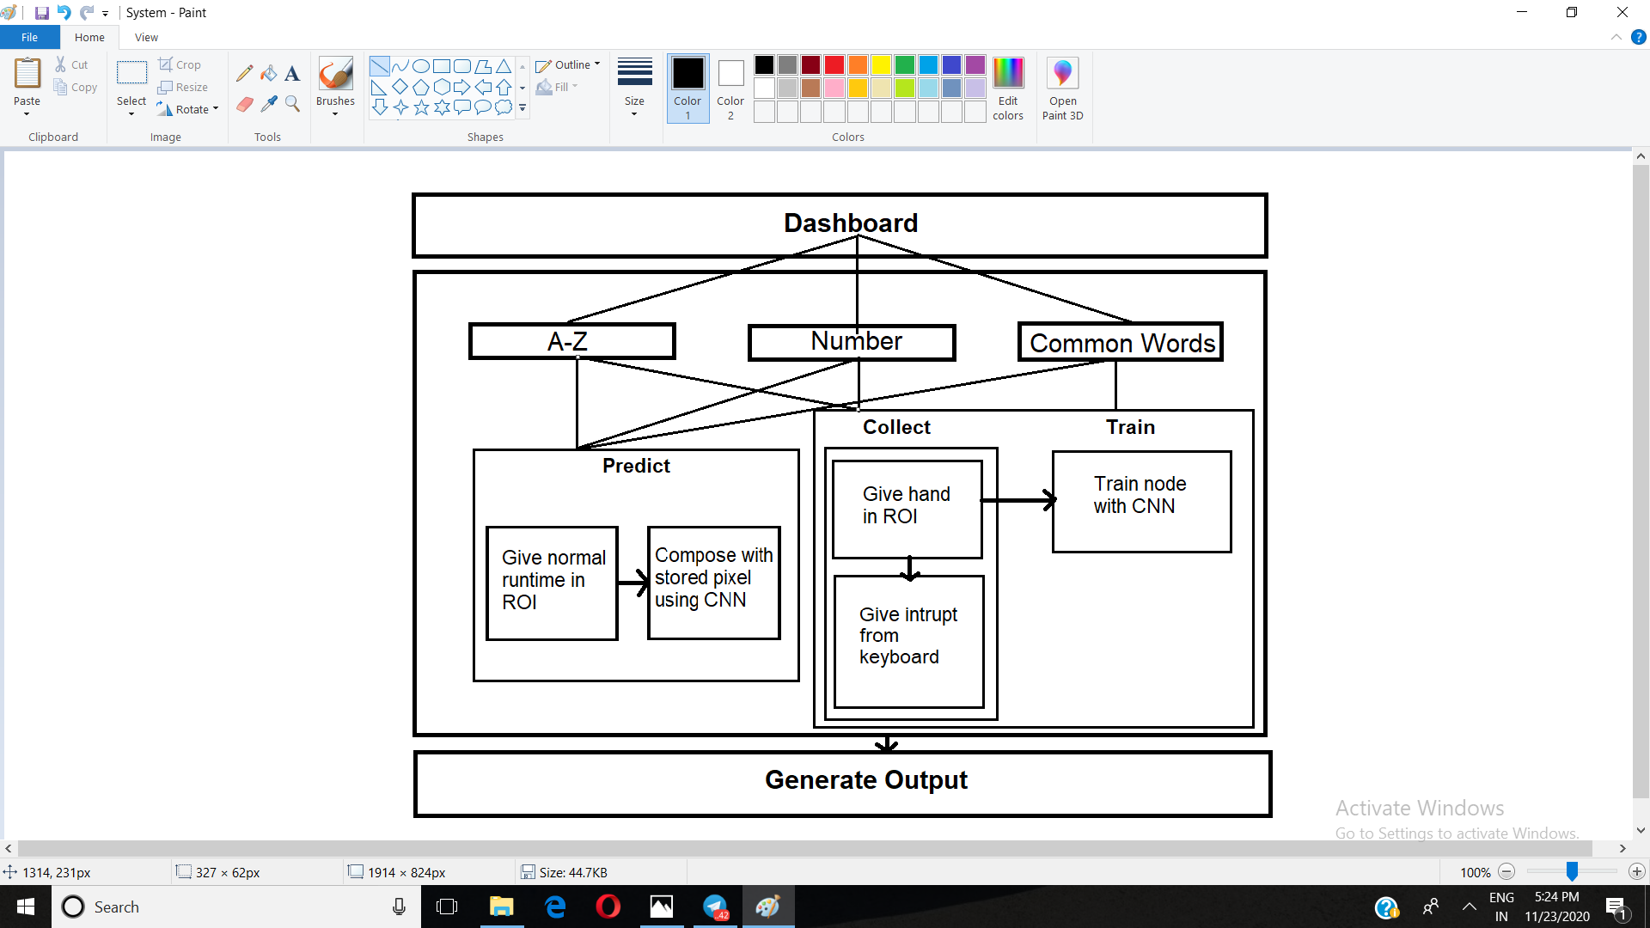

**3.2 USE CASE DIAGRAM**

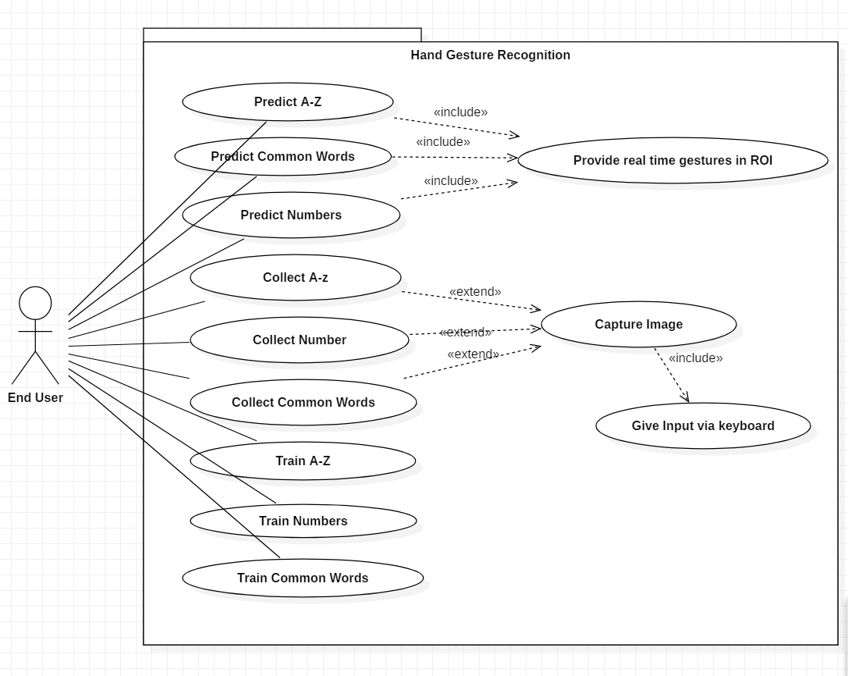

**3.3 ACTIVITY DIAGRAM**

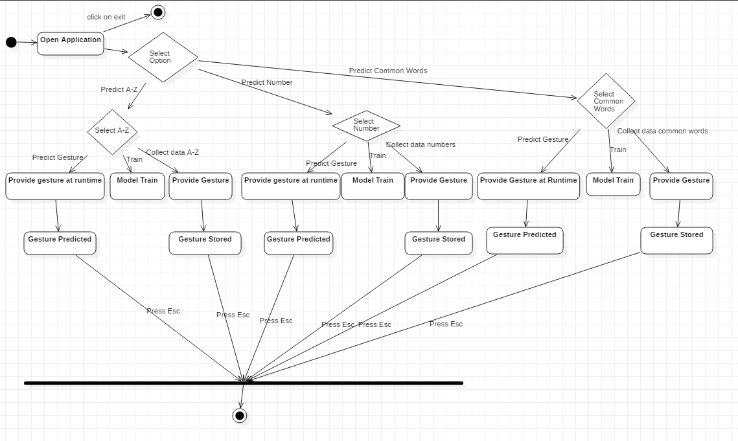

CHAPTER-4

CNN (CONVOLUTION NEURAL NETWORK)

## 4.1. WHAT ARE CONVOLUTIONAL NEURAL NETWORKS?

Convolutional Neural Networks, like neural networks, are made up of neurons with learnable weights and biases.Each neuron receives several inputs, takes a weighted sum over them, pass it through an activation function and responds with an output.

The whole network has a loss function and all the tips and tricks that we developed for neural networks still apply on Convolutional Neural Networks.

## 4.2 HOW DO CONVOLUTIONAL NEURAL NETWORKS WORK?

There are four layered concepts we should understand in Convolutional Neural Networks:

1. Convolution,
2. ReLu,
3. Pooling and
4. Full Connectedness (Fully Connected Layer).

Let’s begin by checking out a simple example:

## Example of CNN:

Consider the image below:

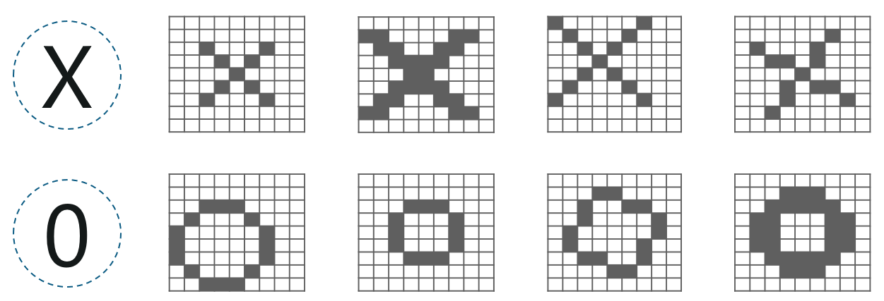

Here, there are multiple renditions of X and O’s. This makes it tricky for the computer to recognize. But the goal is that if the input signal looks like previous images it has seen before, the “image” reference signal will be mixed into, or convolved with, the input signal. The resulting output signal is then passed on to the next layer.

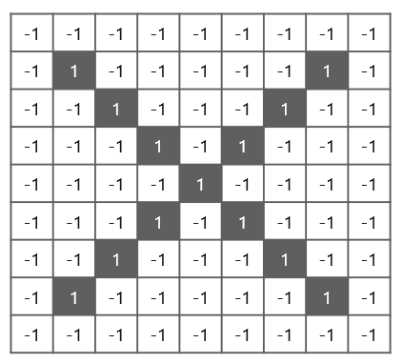

So, the computer understands every pixel. In this case, the white pixels are said to be -1 while the black ones are 1. This is just the way we’ve implemented to differentiate the pixels in a basic binary classification.

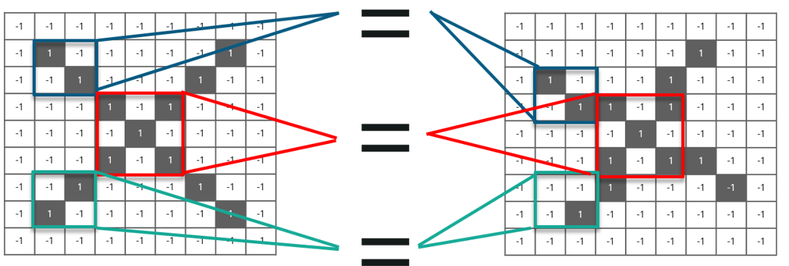

We take small patches of the pixels called filters and try to match them in the corresponding nearby locations to see if we get a match. By doing this, the Convolutional Neural Network gets a lot better at seeing similarity than directly trying to match the entire image.

## ****4.3** **CONVOLUTION OF AN IMAGE****

Convolution has the nice property of being translational invariant. Intuitively, this means that each convolution filter represents a feature of interest (e.g pixels in letters) and the Convolutional Neural Network algorithm learns which features comprise the resulting reference (i.e. alphabet).

We have 4 steps for convolution:

* Line up the feature and the image
* Multiply each image pixel by corresponding feature pixel
* Add the values and find the sum
* Divide the sum by the total number of pixels in the feature

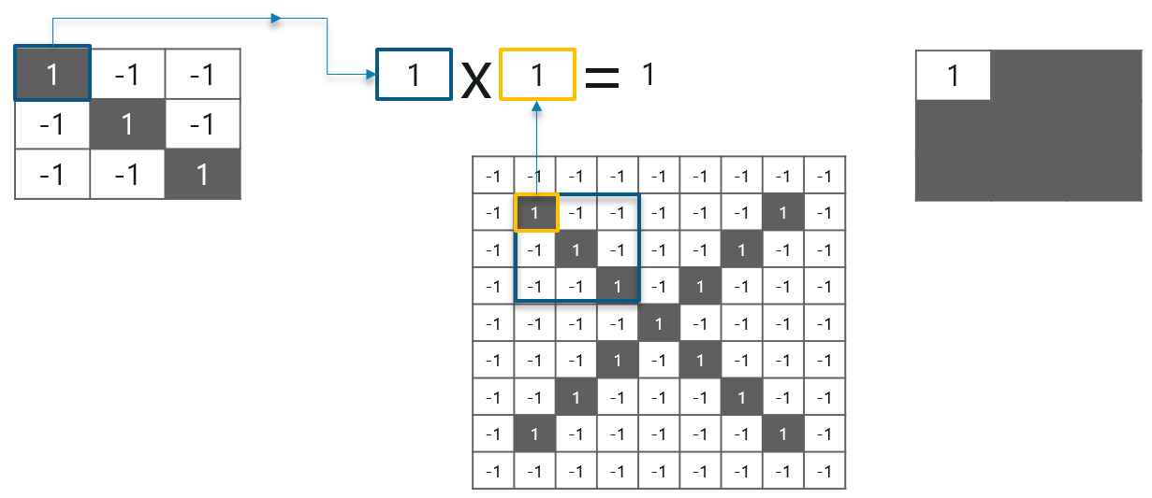

Consider the above image – As you can see, we are done with the first 2 steps. We considered a feature image and one pixel from it. We multiplied this with the existing image and the product is stored in another buffer feature

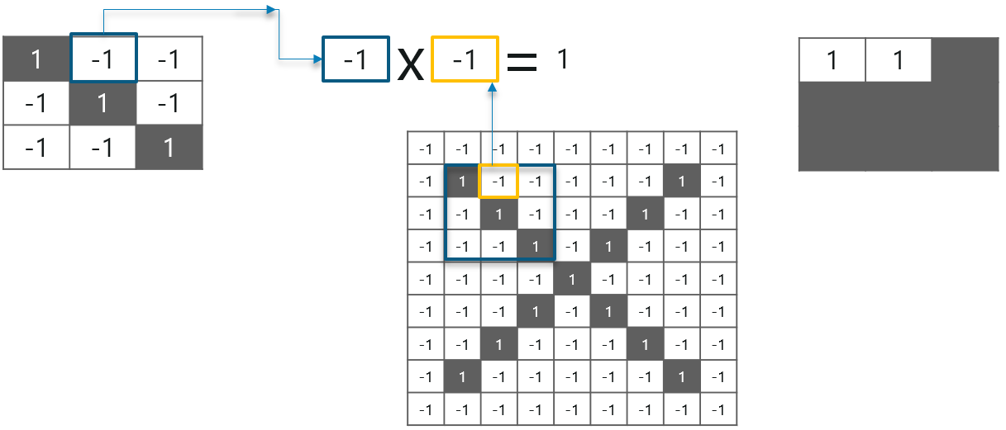

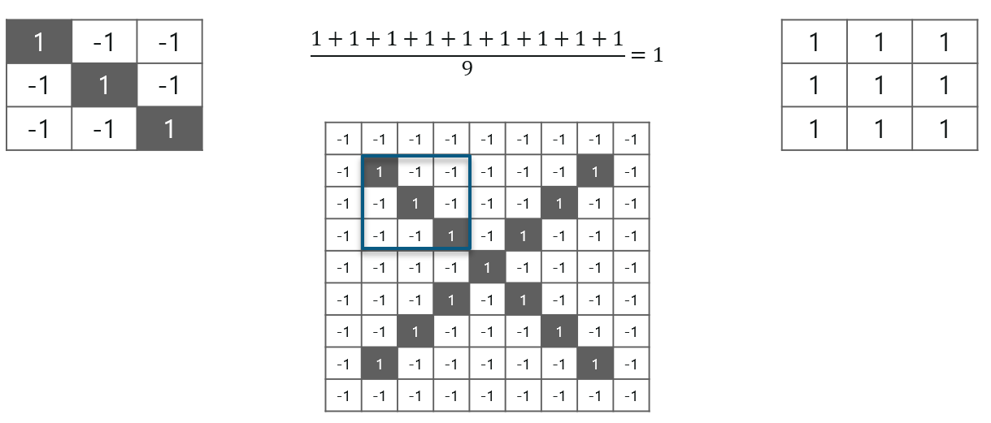

With this image, we completed the last 2 steps. We added the values which led to the sum. We then, divide this number by the total number of pixels in the feature image. When that is done, the final value obtained is placed at the center of the filtered image as shown below:

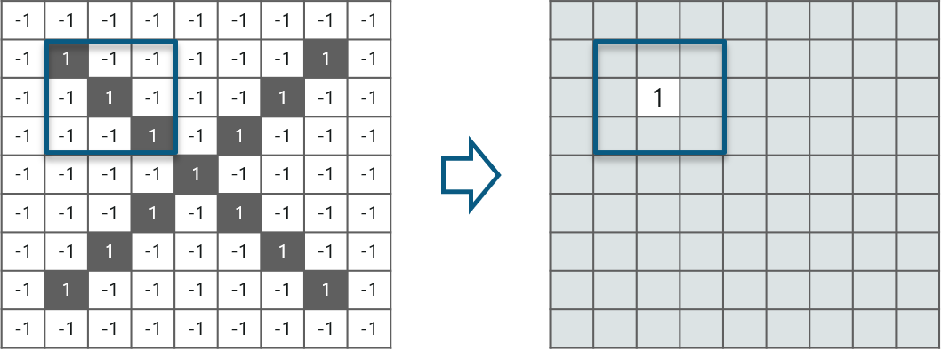

Similarly, we move the feature to every other position in the image and see how the feature matches that area. So after doing this, we will get the output as:

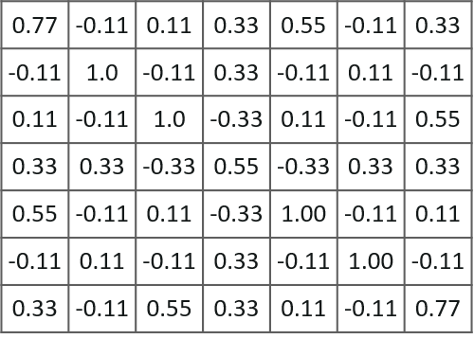

## 4.4 ****RELU LAYER****

ReLU is an activation function. But, what is an activation function?

Rectified Linear Unit (ReLU) transform function only activates a node if the input is above a certain quantity, while the input is below zero, the output is zero, but when the input rises above a certain threshold, it has a linear relationship with the dependent variable.

Consider the below example:

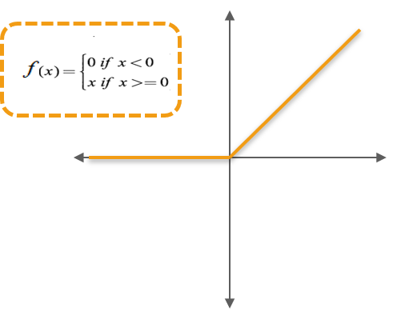

Now, we do the process to all the other feature images as well:

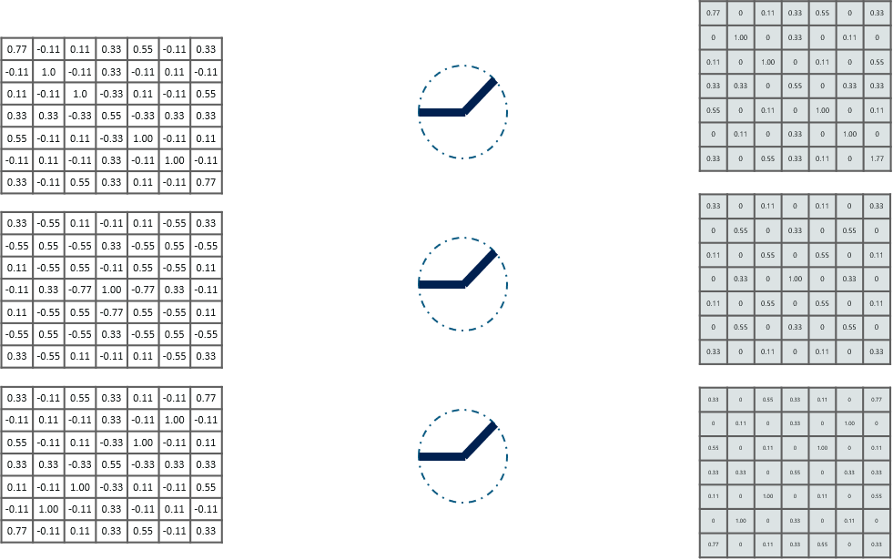

## 4.5 POOLING LAYER

In this layer we shrink the image stack into a smaller size. Pooling is done after passing through the activation layer. We do this by implementing the following 4 steps:

* Pick a window size (usually 2 or 3)
* Pick a stride (usually 2)
* Walk your window across your filtered images
* From each window, take the maximum value

Let us understand this with an example. Consider performing pooling with a window size of 2 and stride being 2 as well.

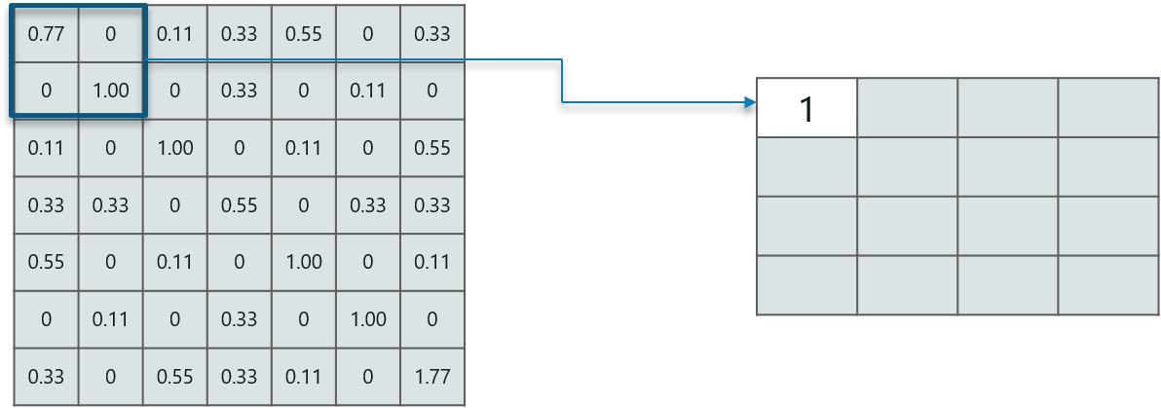

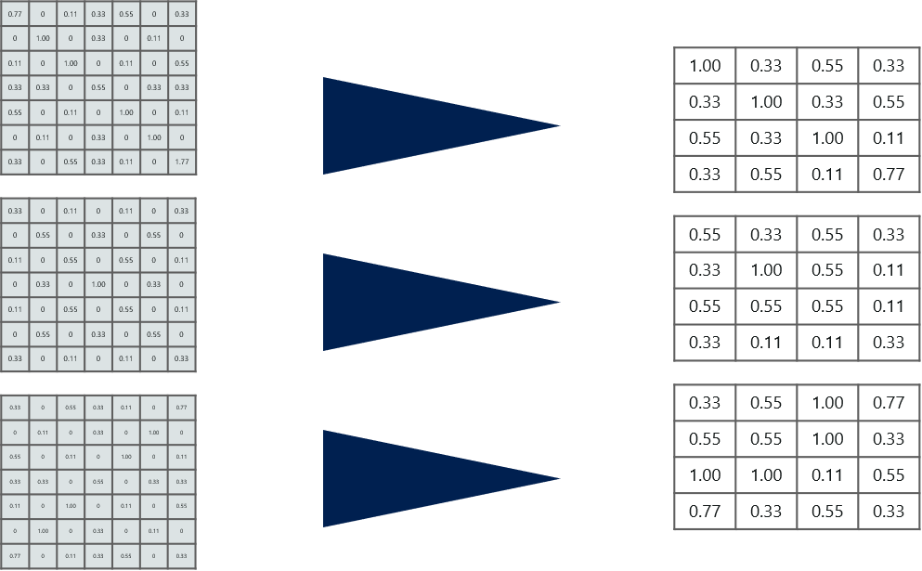

## 4.6 STACKING UP THE LAYERS

So to get the time-frame in one picture we’re here with a 4×4 matrix from a 7×7 matrix after passing the input through 3 layers – Convolution, ReLU and Pooling as shown below:

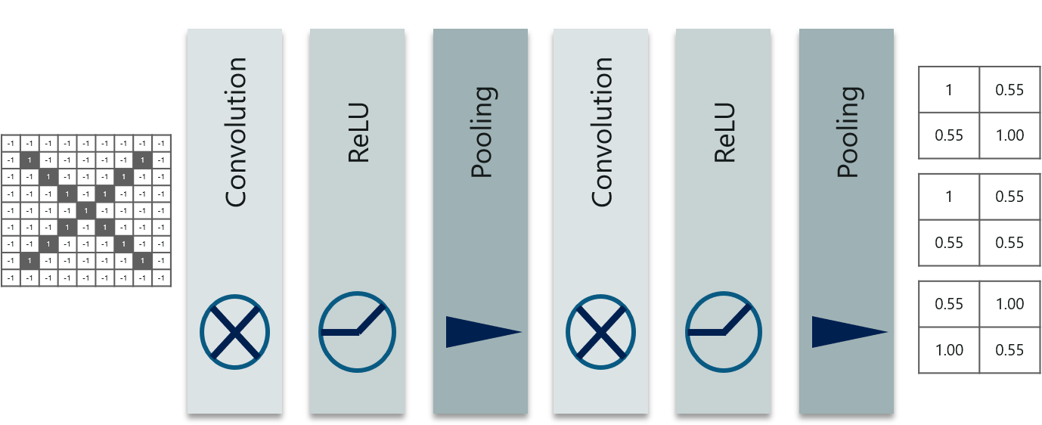

The last layers in the network are fully connected, meaning that neurons of preceding layers are connected to every neuron in subsequent layers.

This mimics high level reasoning where all possible pathways from the input to output are considered.

Also, fully connected layer is the final layer where the classification actually happens. Here we take our filtered and shrinked images and put them into one single list as shown below:

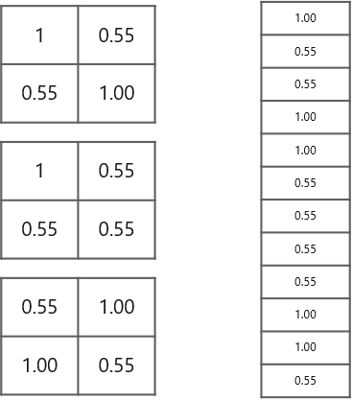

So next, when we feed in, ‘X’ and ‘O’ there will be some element in the vector that will be high. Consider the image below, as you can see for ‘X’ there are different elements that are high and similarly, for ‘O’ we have different elements that are high:

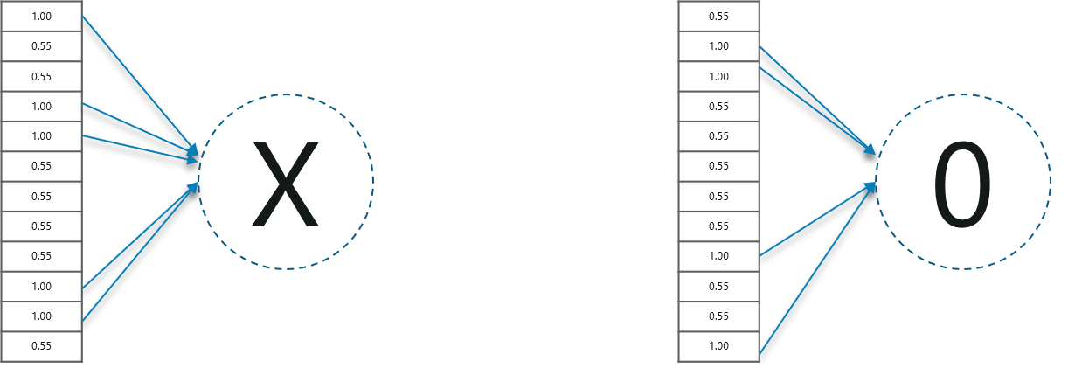

CHAPTER-5

CONTOUR

**5.1 CONTOUR**

The contour of the hand is defined as when the boundary pixels of the given gestures is connected to form a close figure of the hand space. Once we get the contour, it is used for further calculations in the algorithm for prediction of the gesture. In figure we can see that the blue line around the hand gesture given through the webcam is the required contour.



Figure 5.1: Contour Boundary of the Hand

**5.2 CONVEX HULL**

The convex hull of hand gesture is the polygon formed by joining the end points of contour of the hand gesture, as shown in figure, the polygon formed by red curve boundary is the convex hull of hand gesture and green curve boundary is contour of the hand.



Figure 5.2: Convex hull Boundary (Red) of Hand

**5.3 CONVEXITY DEFECTS**

The convexity defect is defined as the difference in the area between the convex hull and contour. The area which is inscribed in the convex hull but not in the contour is defined as the convexity defect of the hand gesture. In figure, the red spots are placed in the convexity defects that lie in between the contour area and hull area. In figure as the number of fingers increases the red spots also increase with the formula of “no. of fingers - 1”, therefore if the number of fingers is 5 then the number of convexity defects are 4.



Figure 5.3: Convexity defects of hand gesture at run time

When the hand is placed in the Region of Interest (ROI), the contour and the convex hull is formed. The fingertips are identified. The angle is calculated between the contour and convex hull of the hand. If the angle is acute Convexity Defect is identified and red spots are placed in the defects (Flow Chart). With the help of these red spots, the output is predicted and displayed on the screen.



Figure 5.4: Process Flow of Contour Algorithm

CHAPTER-6

TESTING

**6.1 UNIT TESTING**

Unit testing is carried out for testing modules constructed from the system design. Each part is compiled using inputs for specific modules. Every module is assembled into a larger unit during the unit testing process. Testing has been performed on each phase of project design and coding. The testing of module interface is carried out to ensure the proper flow of information into and out of the program unit while testing. The temporarily generated output data is ensured that maintains its integrity throughout the algorithm's execution by examining  
the local data structure. Finally, all error-handling paths are also tested.

**6.2 INTEGRATION TESTING**

We usually perform system testing to find errors resulting from unanticipated interaction between the sub-system and system components. Software must be tested to detect and rectify all possible errors once the source code is generated before  
delivering it to the customers. For finding errors, series of test cases must be developed which ultimately uncover all the possibly existing errors. Different software techniques can be used for this process. These techniques provide systematic guidance for designing test that exercise the internal logic of the software components  
and exercise the input and output domains of a program to uncover errors in program function, behavior and performance.  
We test the software using two methods: White Box testing: Internal program logic is exercised using this test case design  
techniques.  
Black Box testing: Software requirements are exercised using this test case design techniques. Both techniques help in finding maximum number of errors with minimal effort and time.

**6.3 TEST CASES**

|  |  |  |  |
| --- | --- | --- | --- |
| **Gesture in ROI** | **Predicted Output** | **Desired Output** | **Pass/Fail** |
| One | One | One | Pass |
| Two | Two | Two | Pass |
| Three | Three | Three | Pass |
| Four | Five | Four | Fail |
| Five | Five | Five | Pass |
| A | A | A | Pass |
| B | B | B | Pass |
| C | K | C | Fail |
| I | J | I | Fail |
| F | F | F | Pass |
| L | L | L | Pass |
| W | M | W | Fail |
| Z | Z | Z | Pass |
| M | M | M | Pass |
| I Love You | I Love You | I Love You | Pass |
| Hi | Hi | Hi | Pass |
| Call Me | Call Me | Call Me | Pass |
| Nope | Nope | Nope | Pass |

**6.4. APPLICATION’S UI**

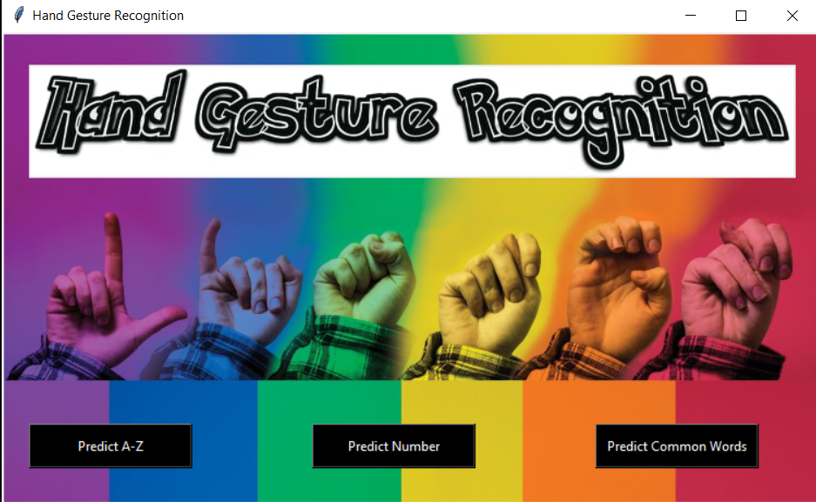

Figure 6.1: Application UI

**6.4.1 PREDICT A-Z WINDOW**

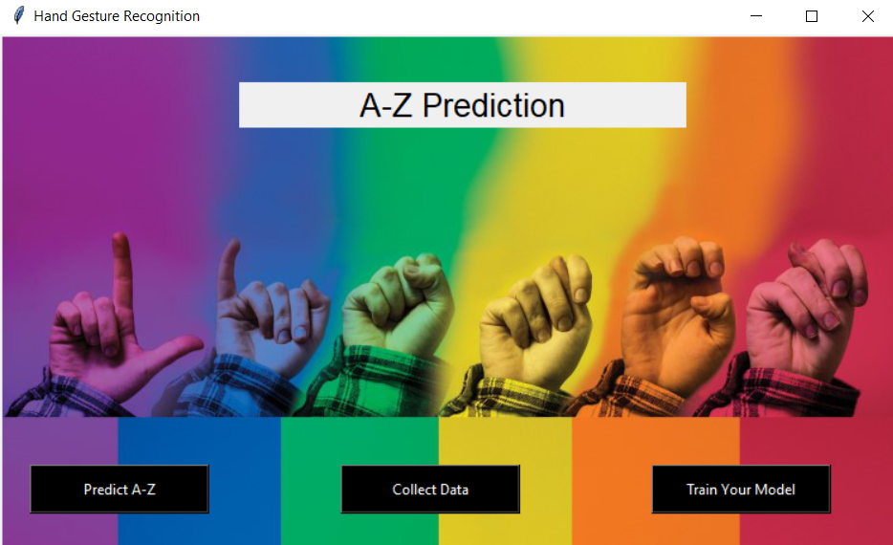

Figure 6.2: A-Z UI

**6.4.2 PREDICT NUMBER WINDOW**

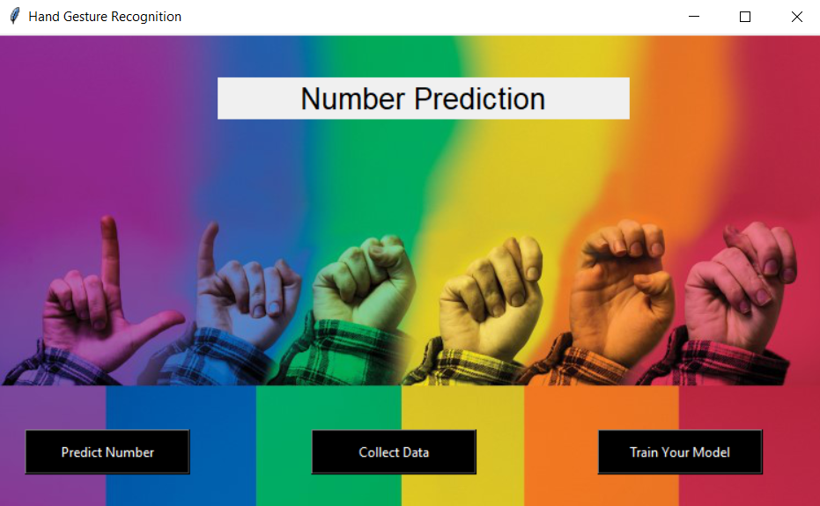

Figure 6.3: Number UI

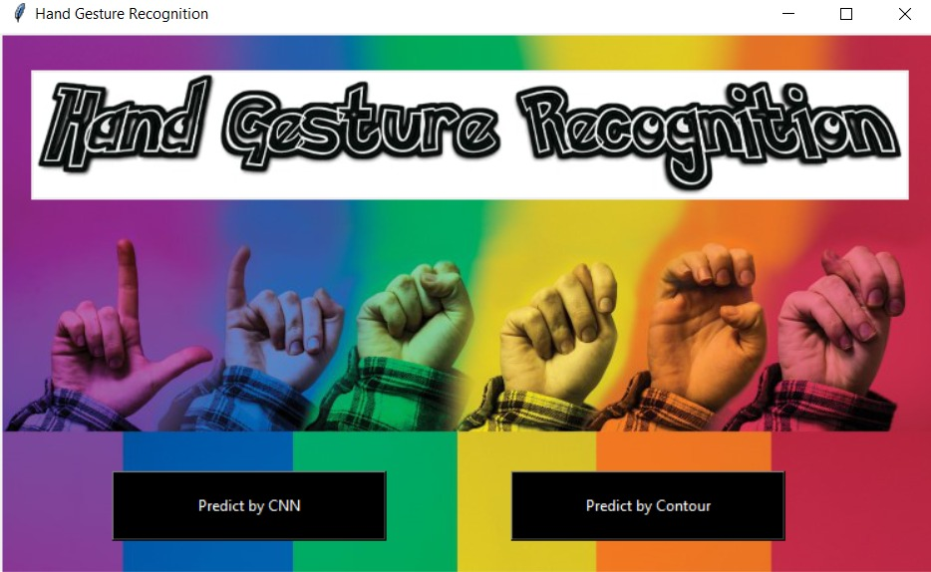

Figure 6.4: CNN and Contour UI for Numbers

**6.4.3 PREDICT COMMON-WORDS WINDOW**

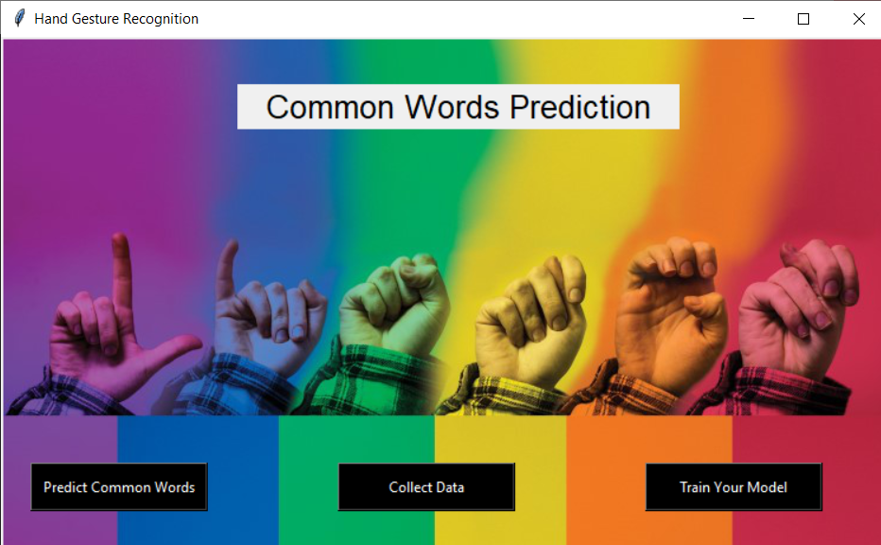

Figure 6.5: Common Words UI

**CHAPTER-7**

**RESULTS AND ANALYSIS**

The below images show the prediction of the gestures on the screen when the hand is put in the ROI. The gestures of number, common words and alphabets are predicted with the help of CNN algorithm and the numbers are also predicted with the help of Contour algorithm and at last the accuracy of both the algorithms are calculated.

**7.1 PREDICTION OF A-Z (ALPHABETS)**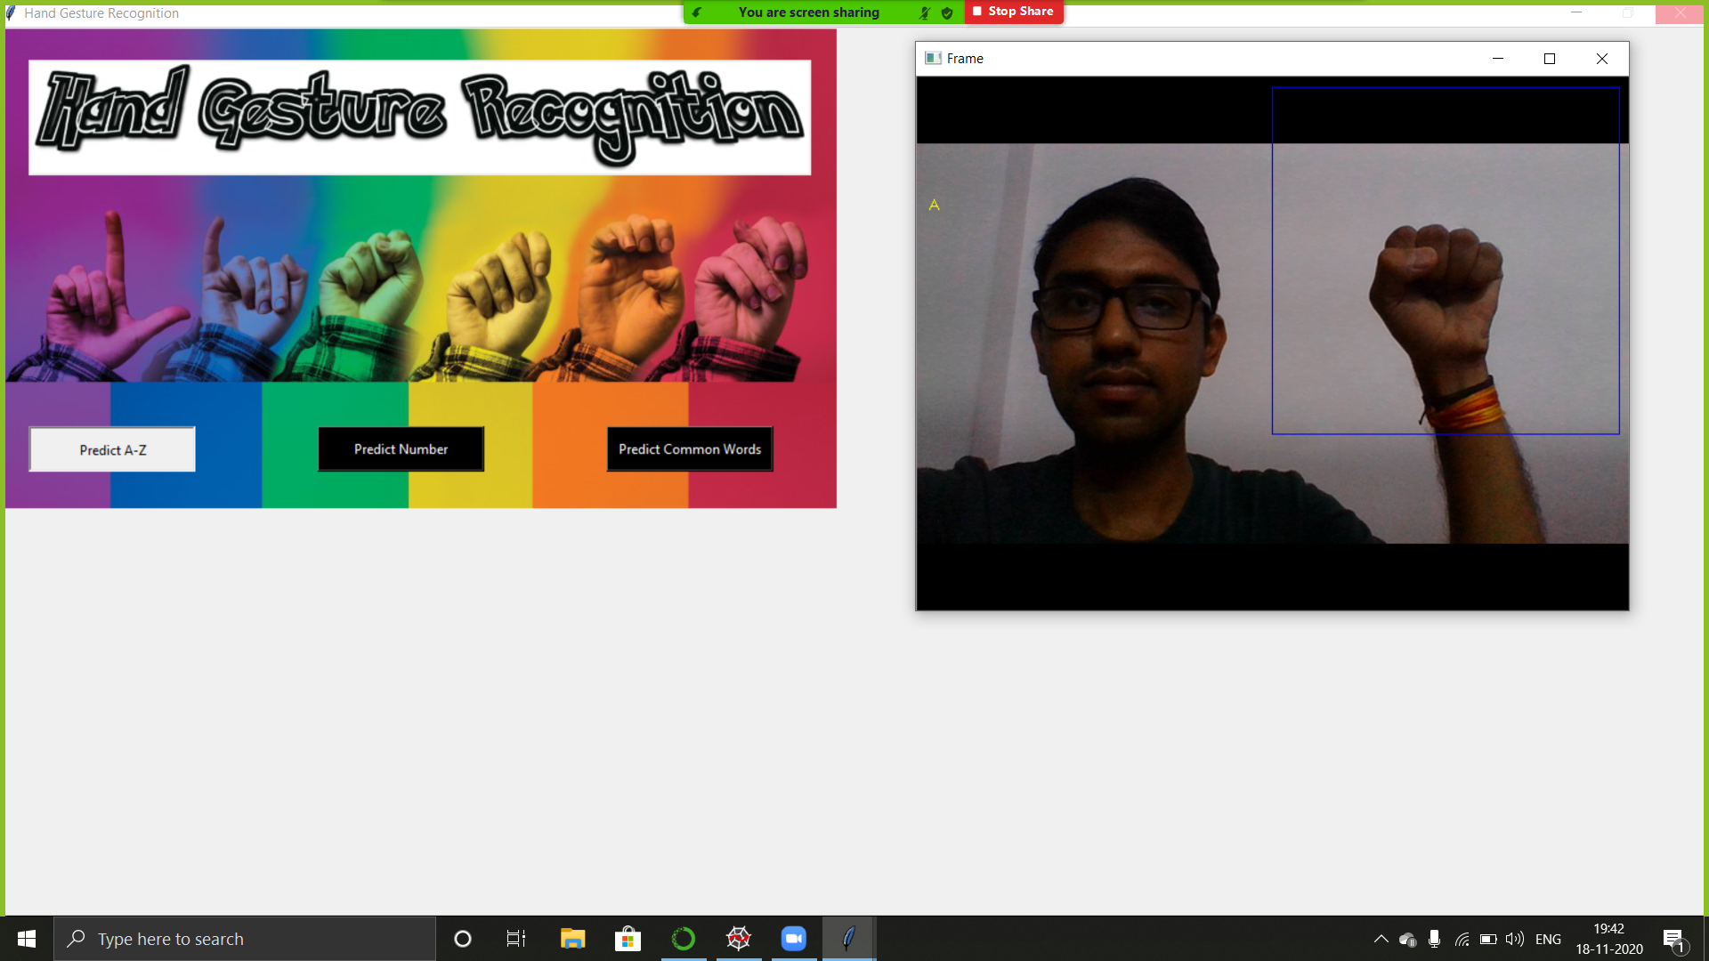

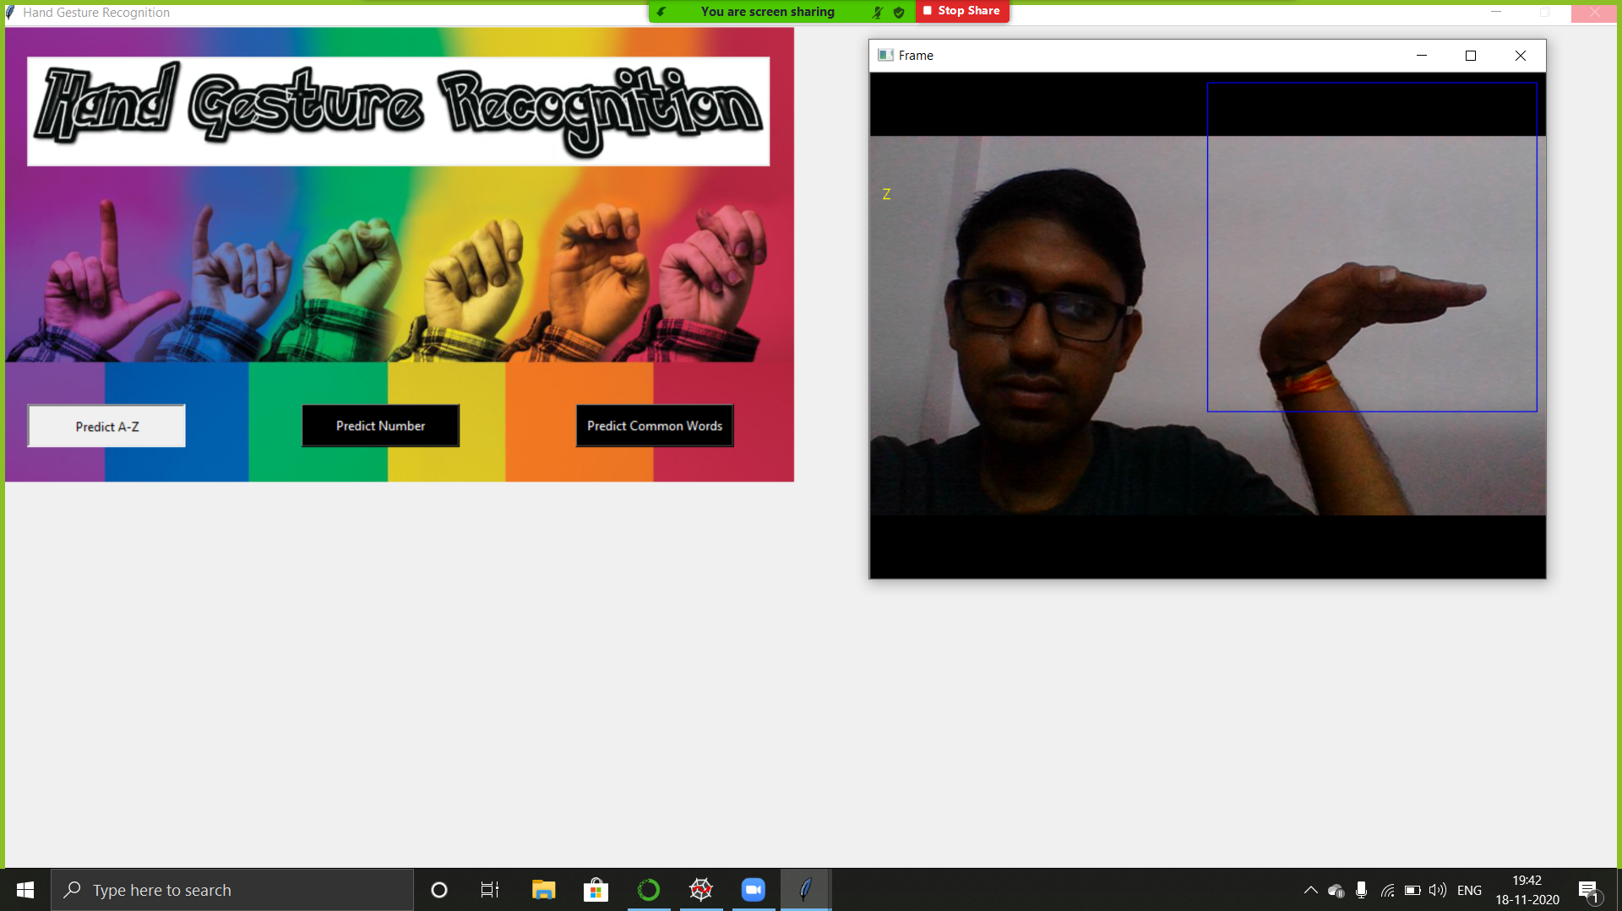

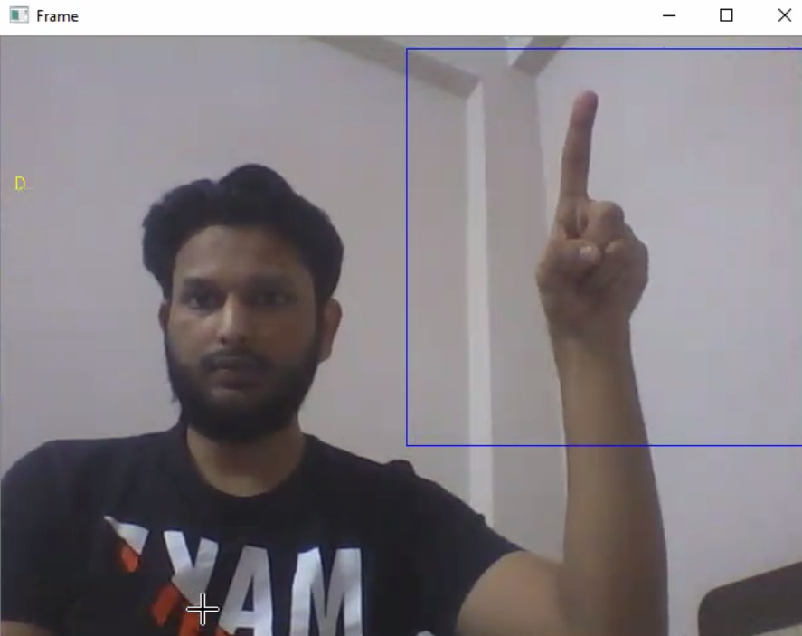

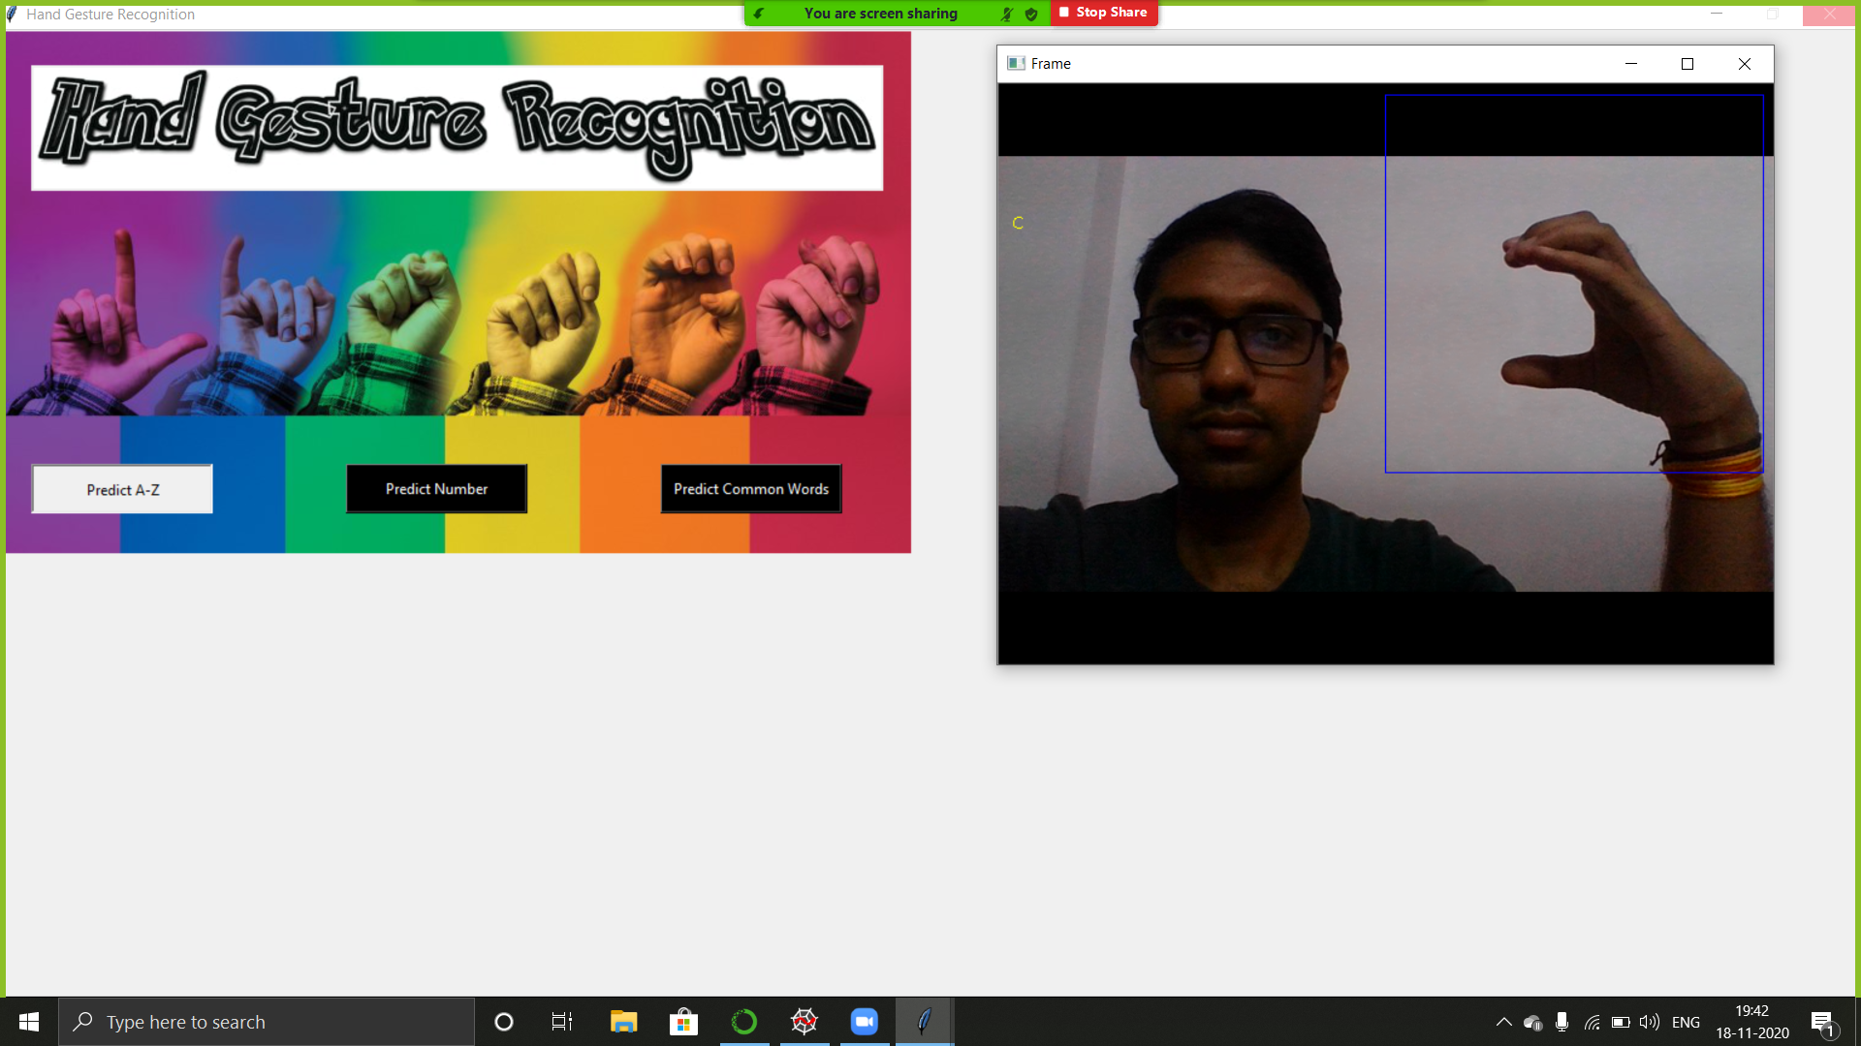

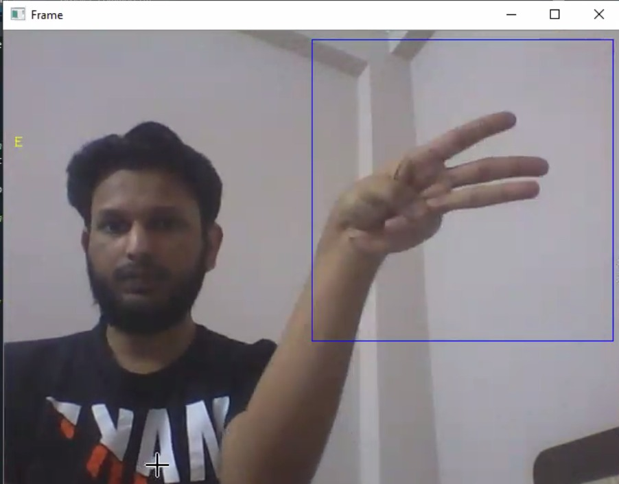

**7.2.1 PREDICTION OF 1-5 (NUMBERS) BY CNN**





**7.2.2 PREDICTION OF 1-5 (NUMBERS) BY CONTOUR**





**7.3 PREDICTION OF COMMON WORDS**

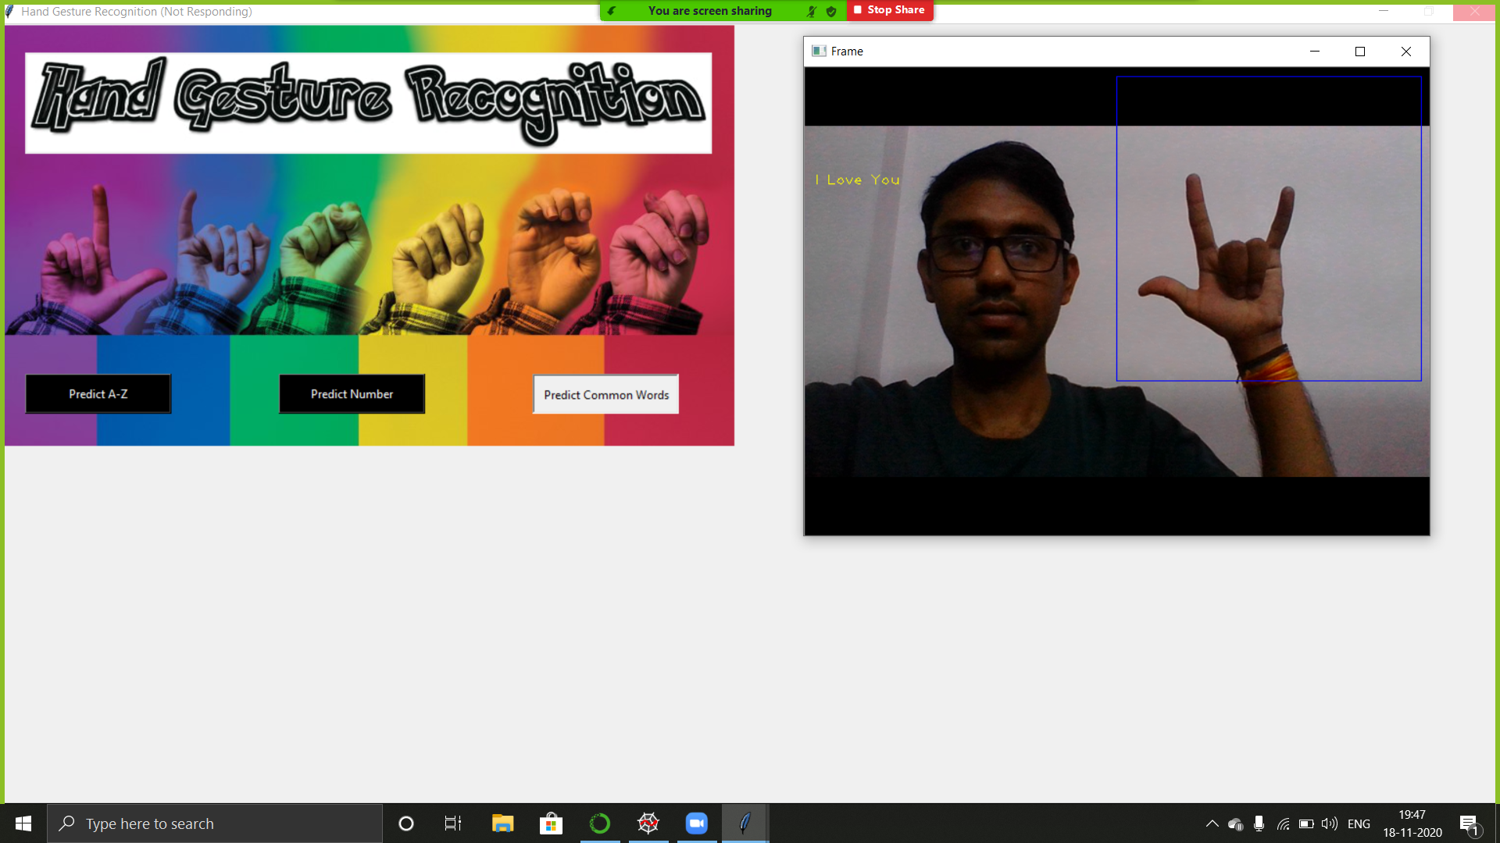

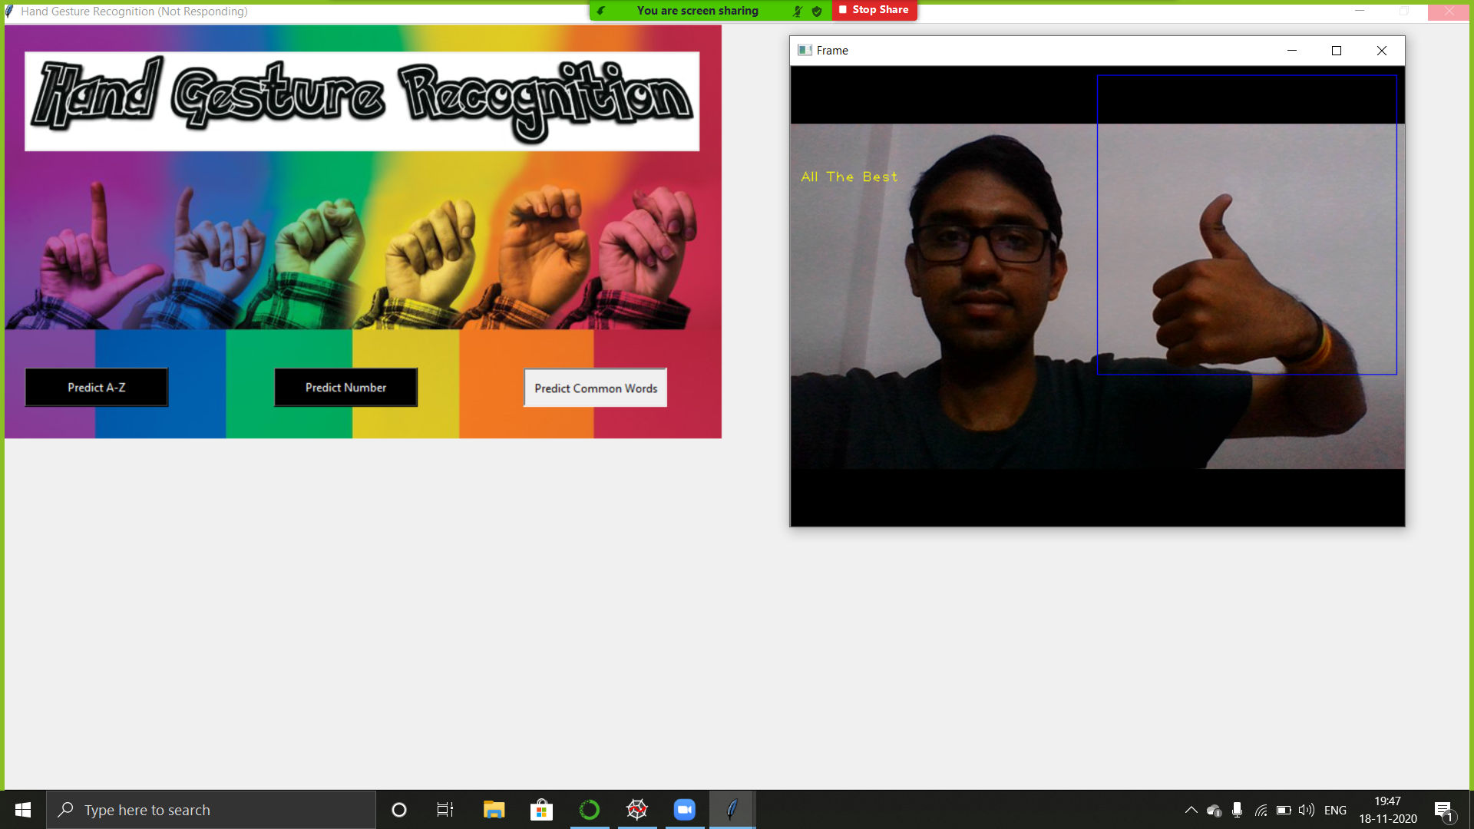

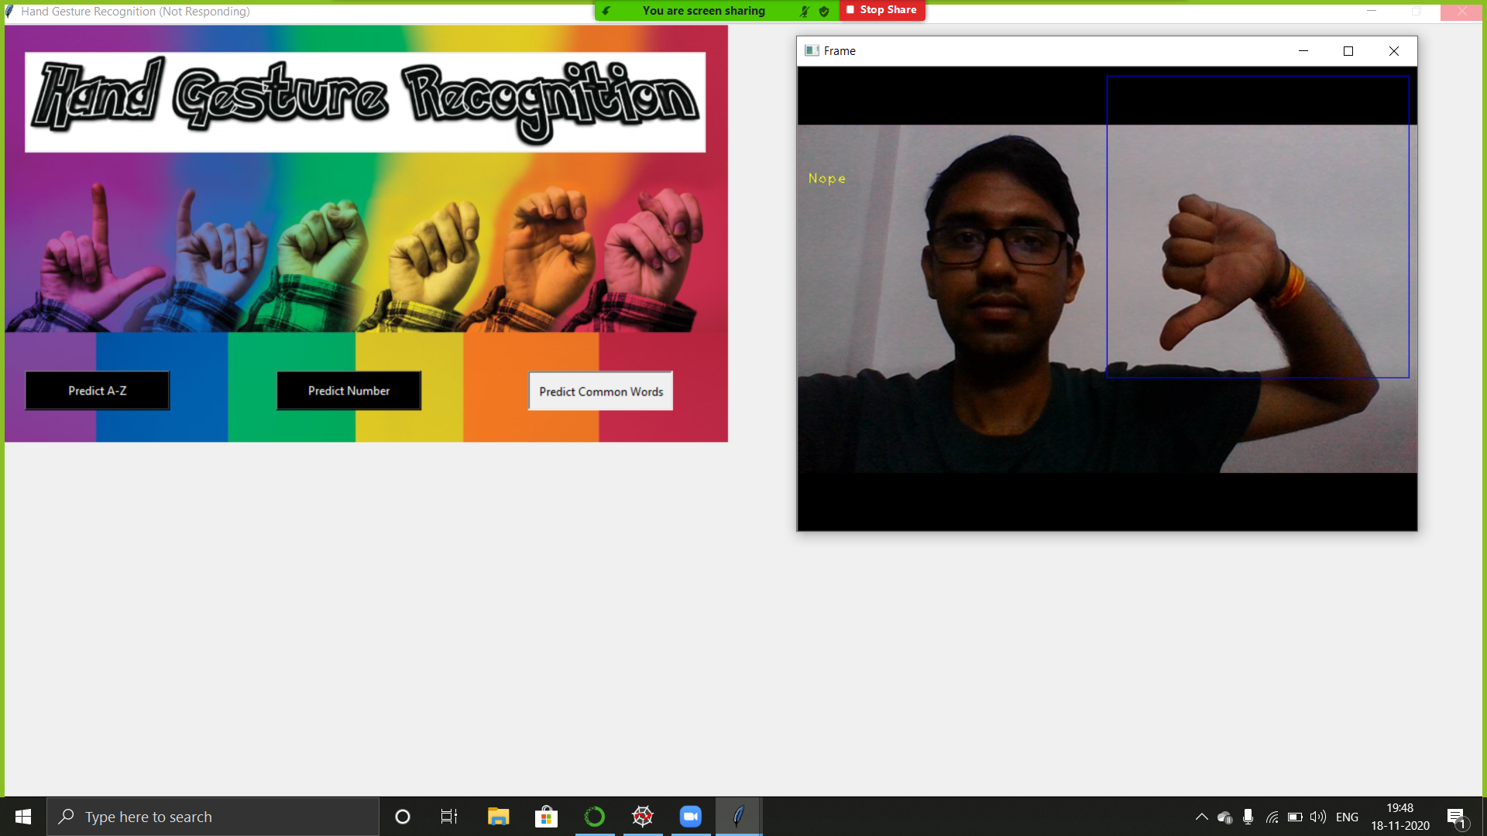

**7.4 DATASET USED**

Using collect module as shown in image we created our own dataset.

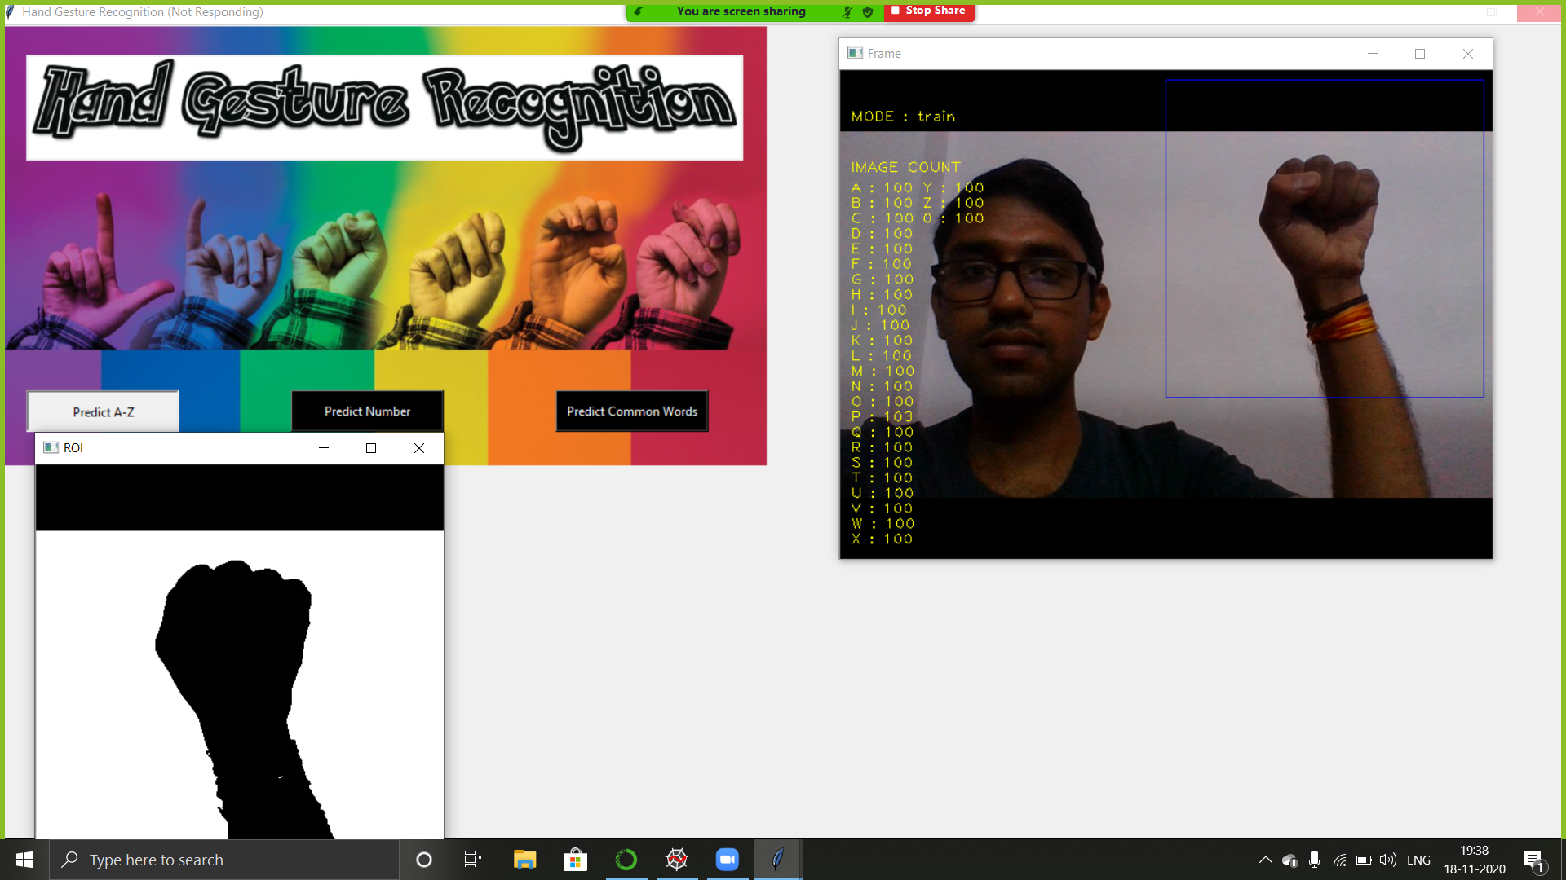

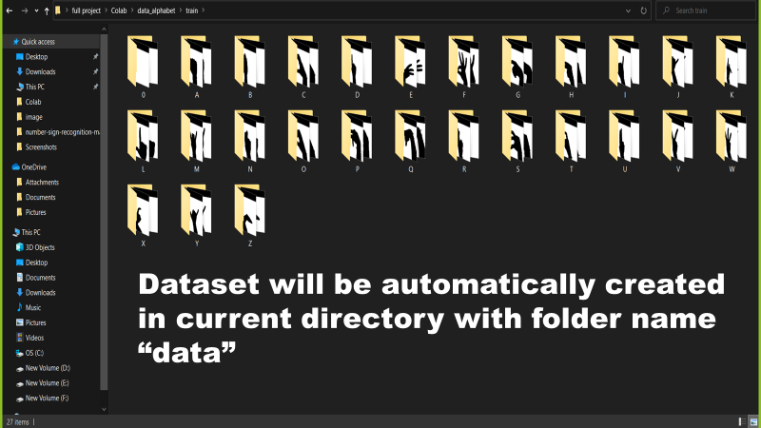

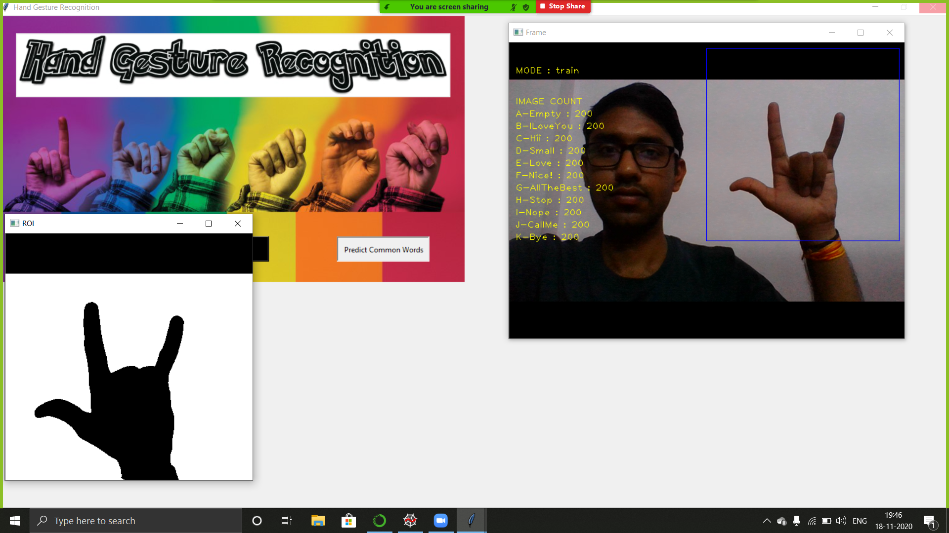

7.5 ACCURACY

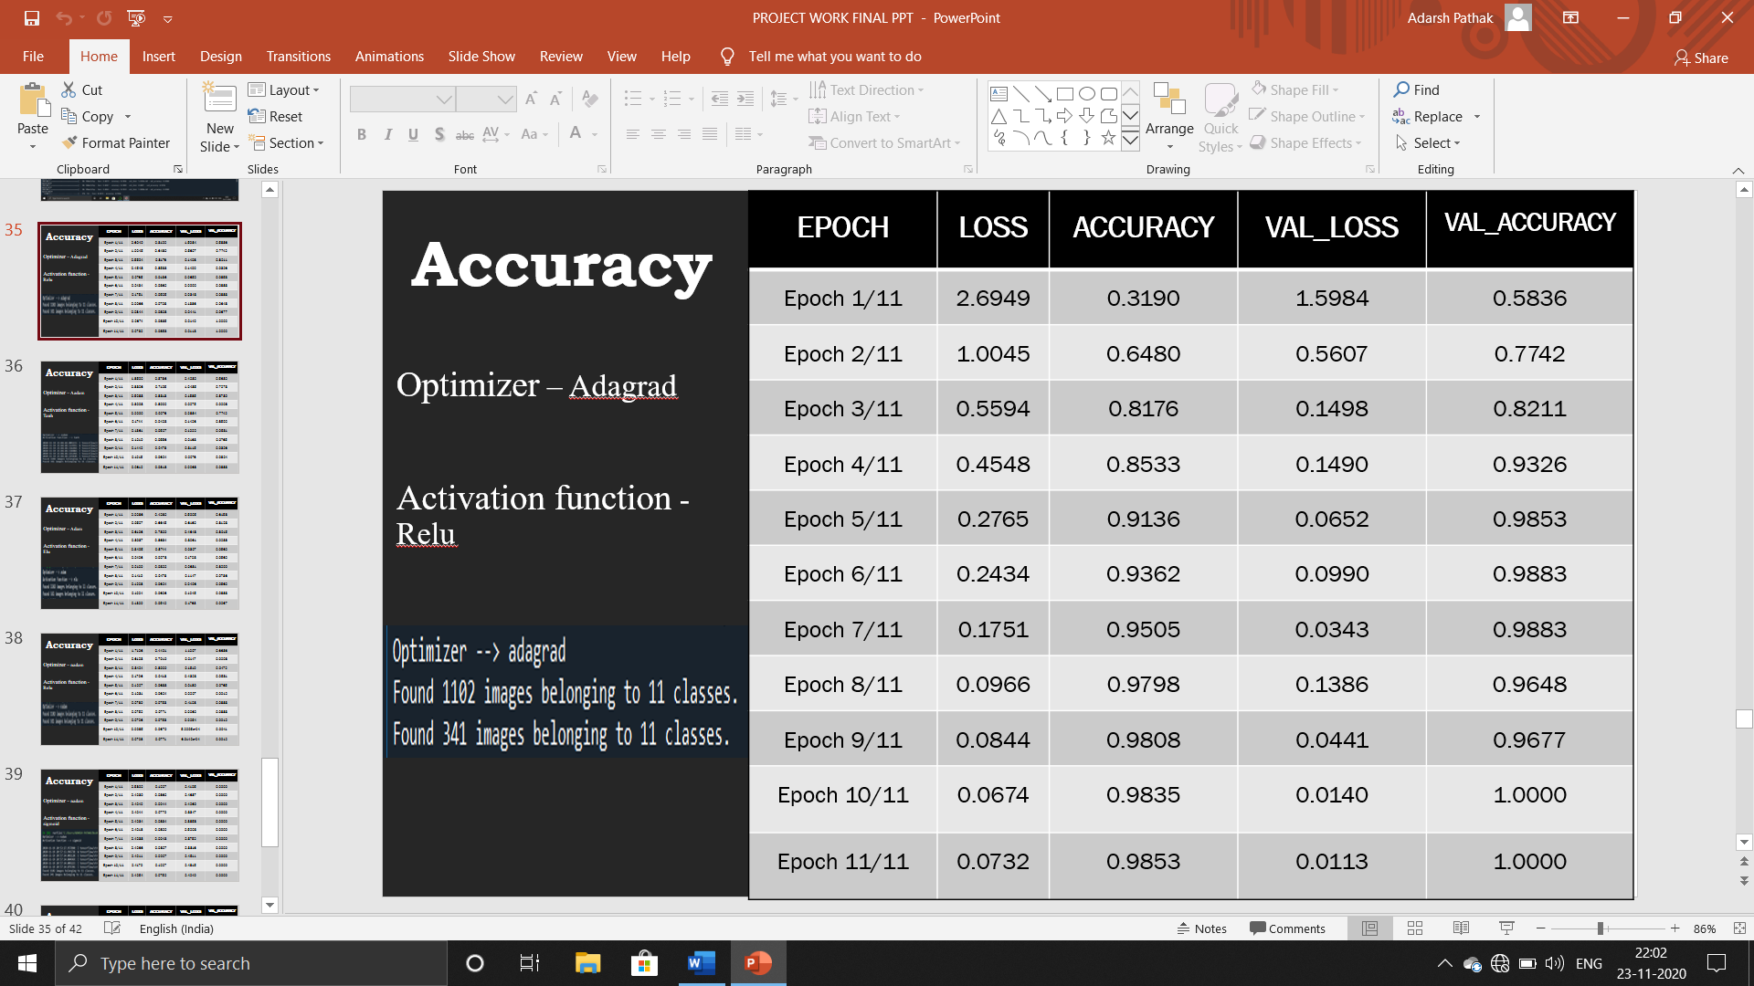

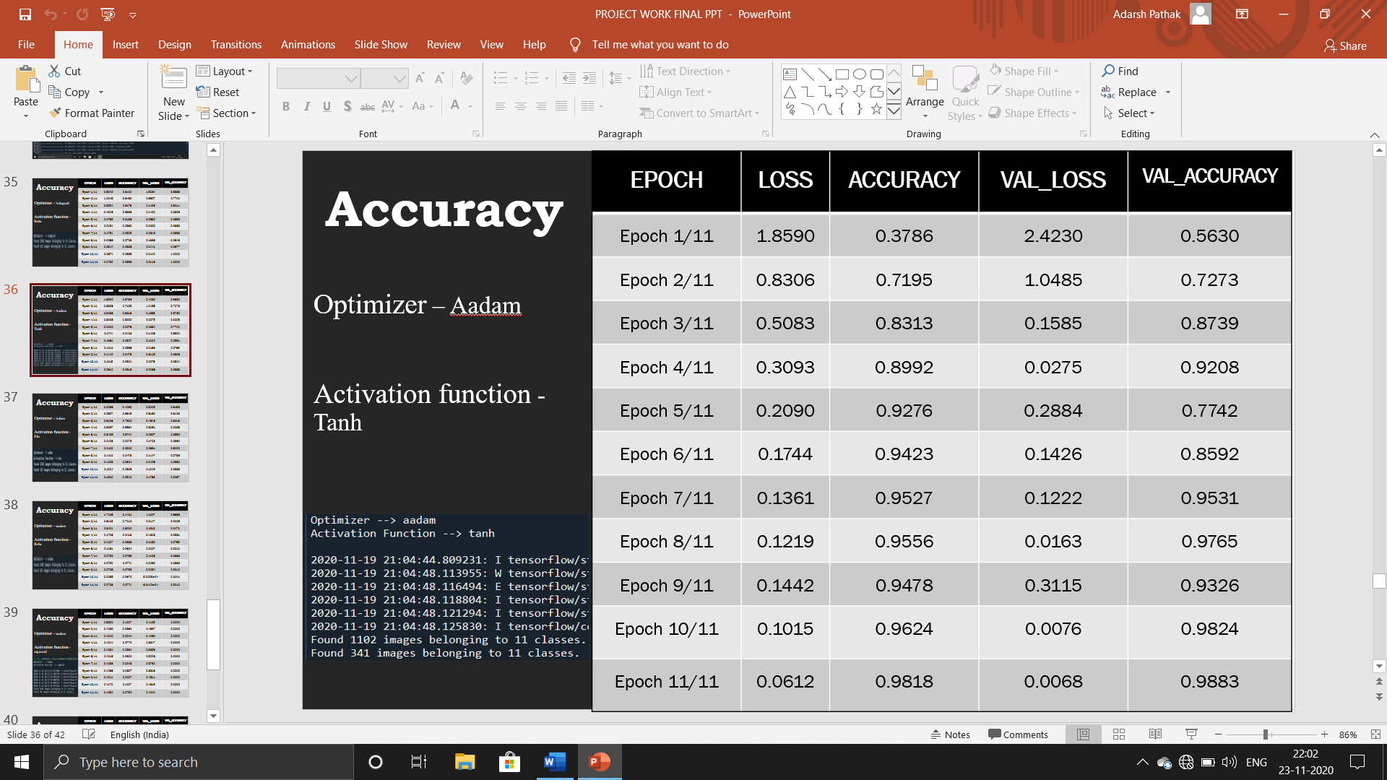

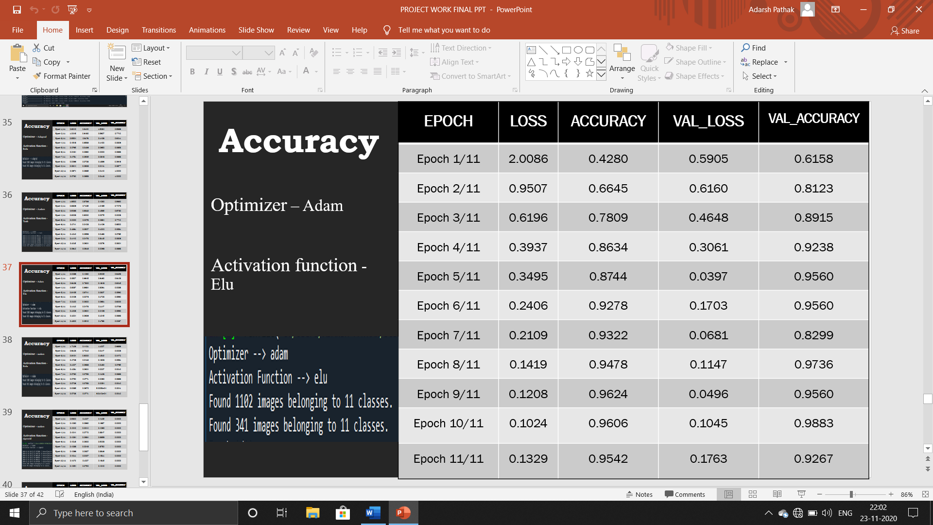

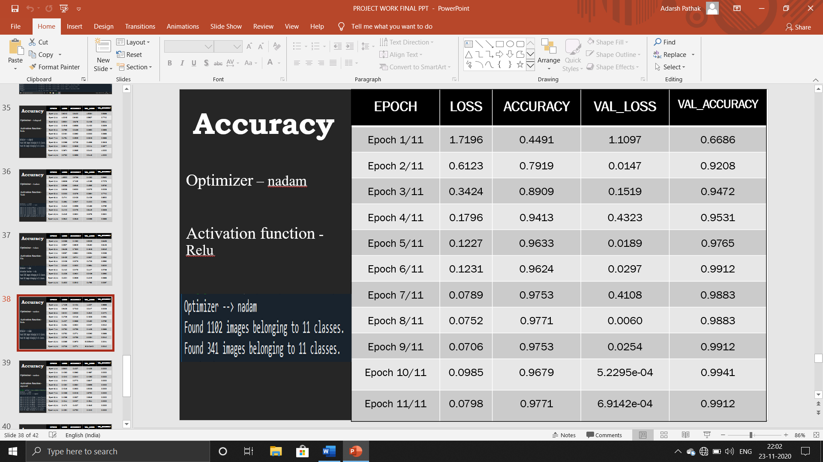

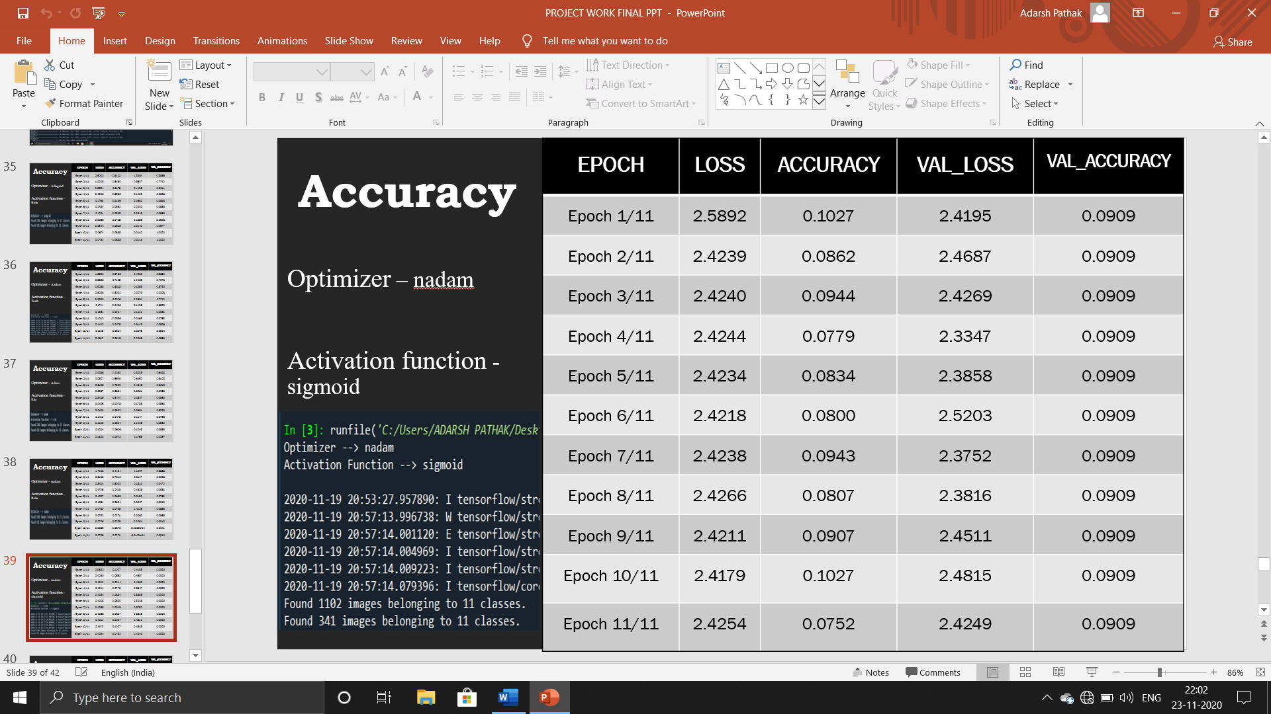

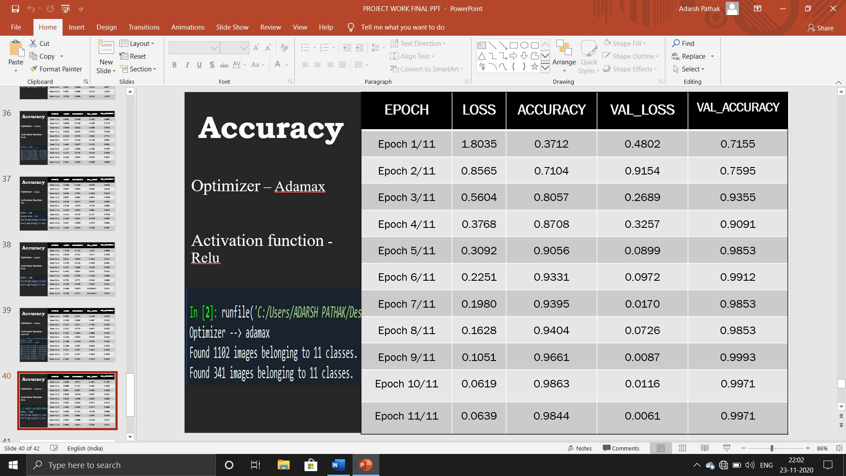

CHAPTER-8

LIMITATIONS AND FUTURE SCOPE

8.1 LIMITATIONS

* This project is working on image currently, further development can lead to detecting the motion of video sequence and assigning it to a meaningful sentence with TTS assistance.
* The adaptiveness of image capturing in low light is bad, therefore the prediction is affected.
* The training of model consumes lot of time, therefore a GPU is required.
* The gestures which are in motion cannot be detected.
* A clear or a plain background is required in ROI to capture real time image to predict more efficiently.
* Contours are not suitable for predicting Alphabets and Common words.

**8.2 FUTURE SCOPE**

* It can be integrated with various search engines and texting application such as google, WhatsApp. So that even the deaf people could be able to chat with other persons, or query something from web just with the help of gesture.
* This project is working on image currently, further development can lead to detecting the motion of video sequence and assigning it to a meaningful sentence with TTS assistance.
* It can be integrated with chatbots like SIRI, google assistant.
* Devices can be used without keyboard, mouse or touch.

**CHAPTER-**9

CONCLUSION

From this project/application we have tried to overshadow some of the major problems faced by the disabled persons in terms of talking. We found out the root cause of why they can’t express more freely. The result that we got was the other side of the audience are not able to interpret what these persons are trying to say or what is the message that they want to convey.

Thereby this application serves the person who wants to learn and talk in sign languages. With this application a person will quickly adapt various gestures and their meaning as per ASL standards. They can quickly learn what alphabet is assigned to which gesture. A user need not be a literate person if they know the action of the gesture, they can quickly form the gesture and appropriate assigned character will be shown onto the screen.

Concerning to the implementation, we have used TensorFlow framework, with keras API. And for the user feasibility complete front-end is designed using Tkinter. Appropriate user-friendly messages are prompted as per the user actions along with what gesture means which character window.

The comparison presented in this project between CNN and Contour algorithm shows that in less number of gestures the Contour algorithm has better accuracy than CNN whereas in more number of gestures the CNN has much better accuracy than Contour. The accuracy of CNN for less number of gestures can be improved by increasing the size of dataset.

REFERENCES

[1] Deepak K. Ray, Mayank Soni, Prabhav Johri, Abhishek Gupta, “Hand Gesture Recognition using Python”, International Journal on Future Revolution in Computer Science & Communication Engineering ISSN: 2454-4248 Volume: 4 Issue: 6.

[2] S.G.Rayo, “Hand Gestures and Hand Movement Recognition for Multimedia Player Control”, February 2008, unpublished thesis.

[3] T.-N. Nguyen, D.-H. Vo, H.-H. Huynh, and J. Meunier, “Geometry-based static hand gesture recognition using support vector machine,” In Proc. The 13th International Conference on Control Automation Robotics & Vision, Singapore, December 10–12, 2014.

[4] Hung-Yuan Chung, Yao-Liang Chung, Wei-Feng Tsai, “An Efficient Hand Gesture Recognition System Based on Deep CNN,” 2019 IEEE International Conference on Industrial Technology (ICIT).

[5] https://www.edureka.co/blog/convolutional-neural-network/ (Date of access: 23rd March 2021)

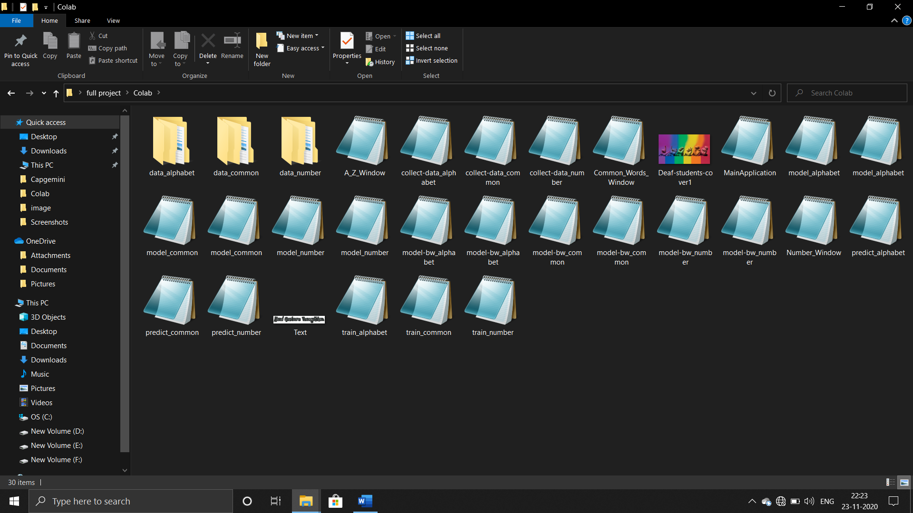APPENDIX

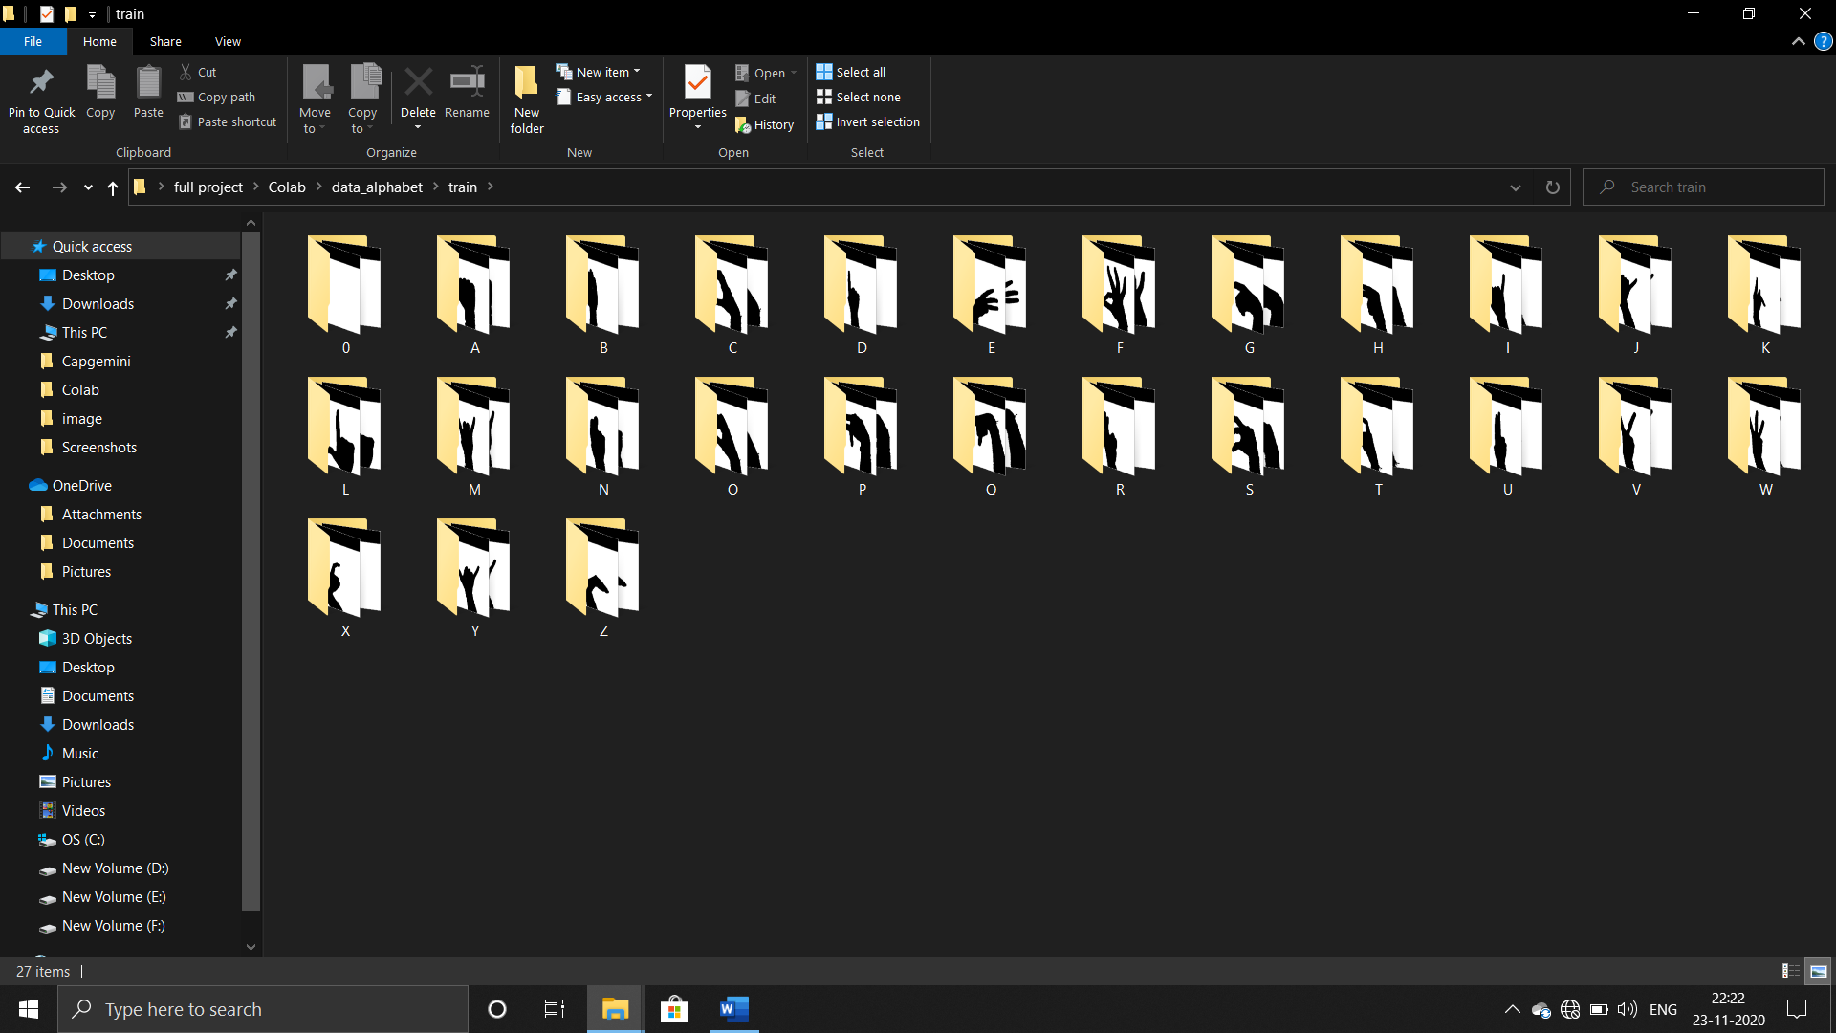 Appendix 1: Project folder

Appendix 2: Dataset folder of alphabet

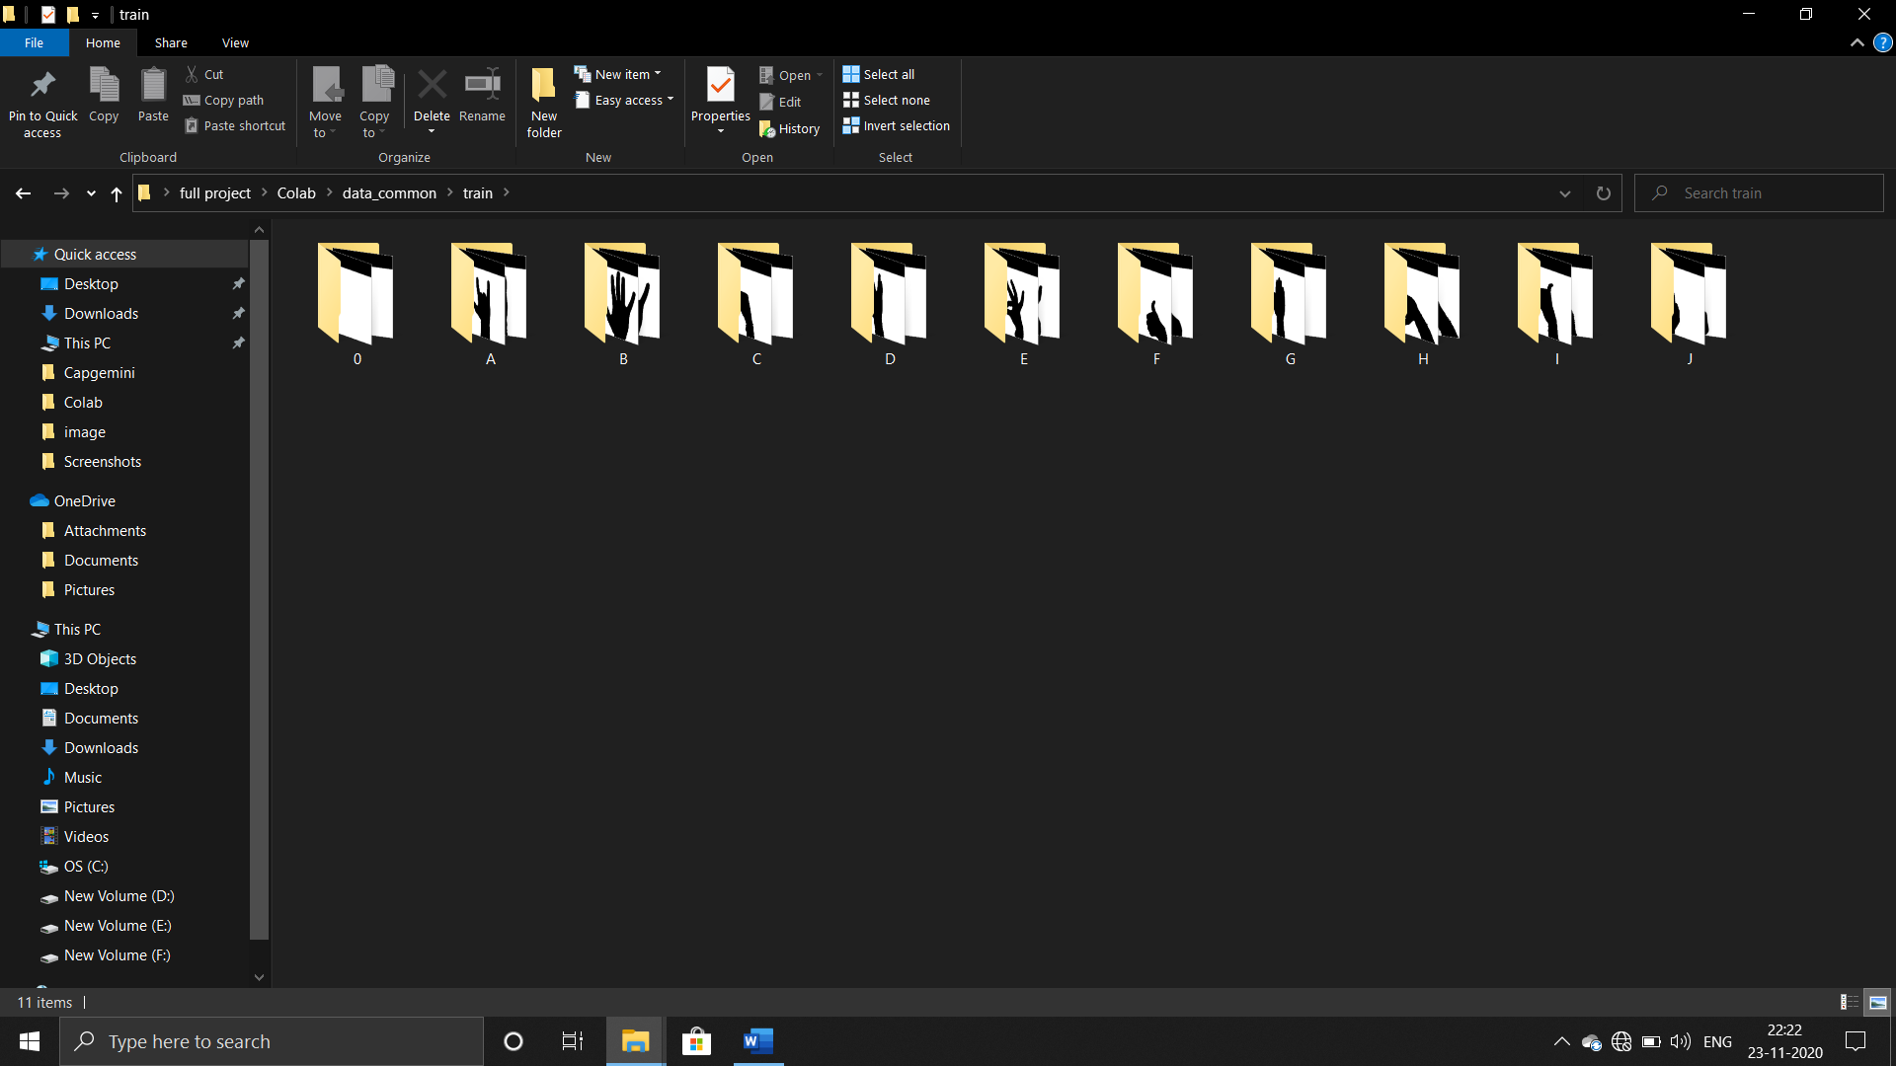 Appendix 3: Dataset of common words

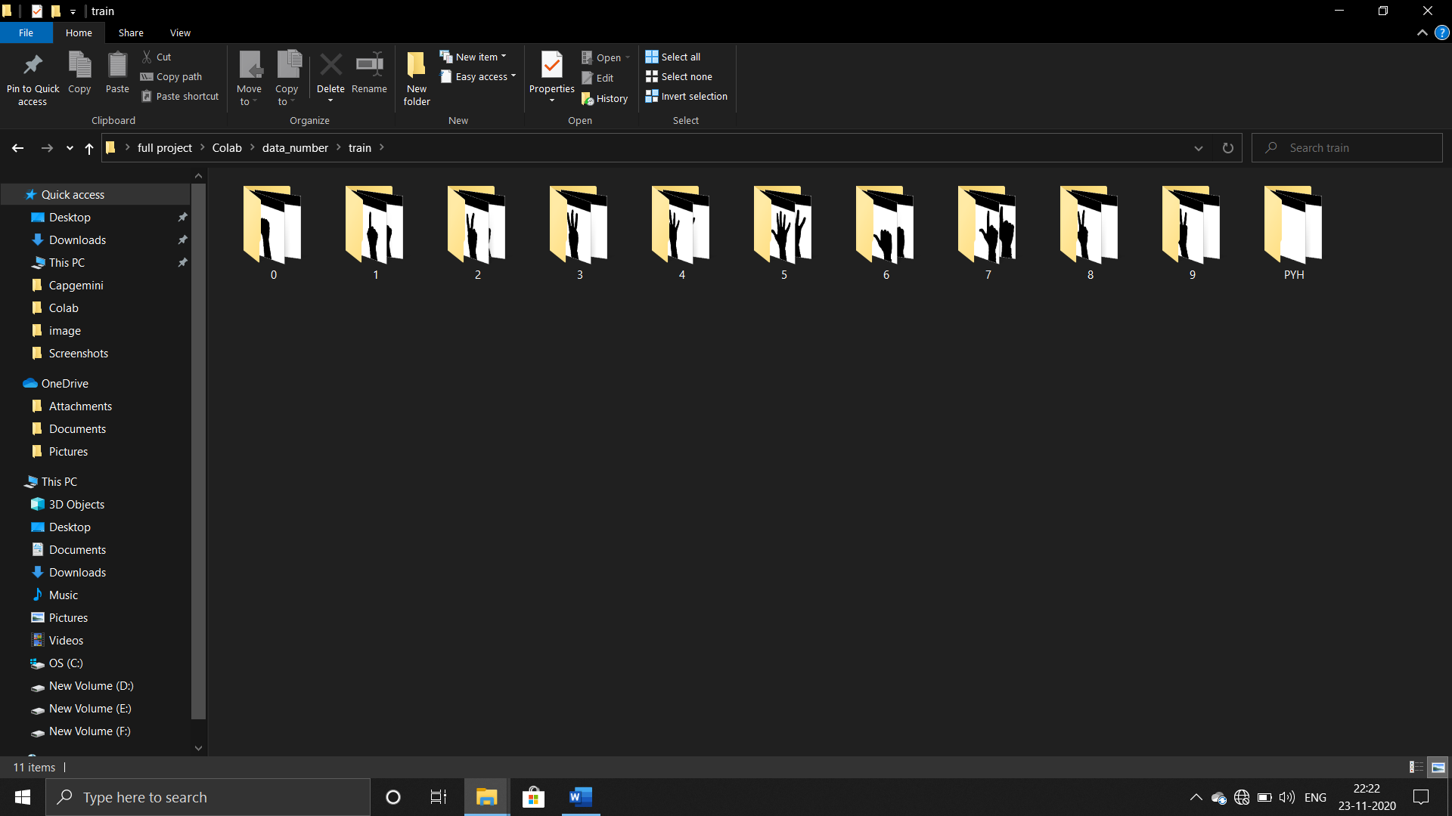

Appendix 4: Dataset of numbers(0-9)

Appendix 5: Dataset of common words(“I LOVE YOU”)

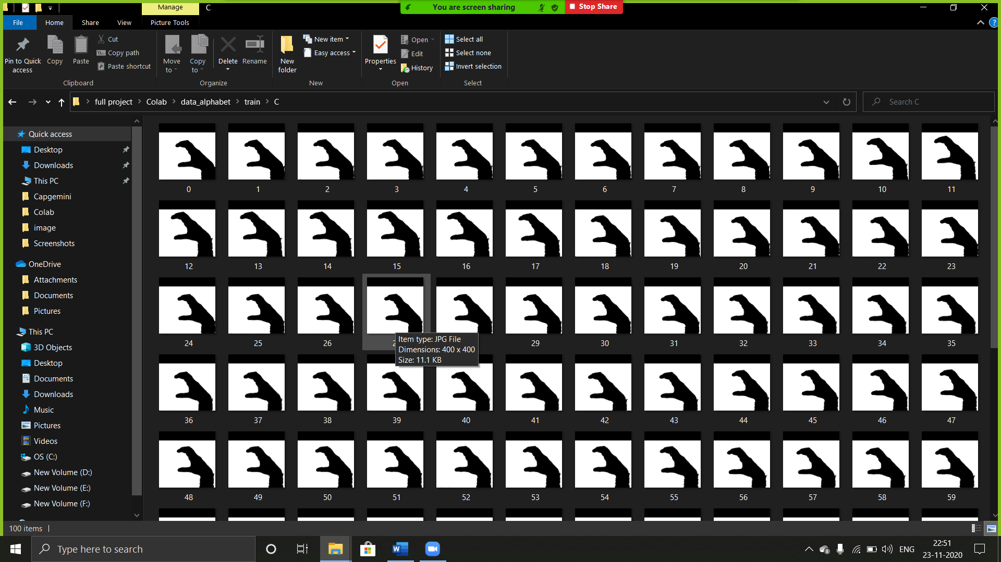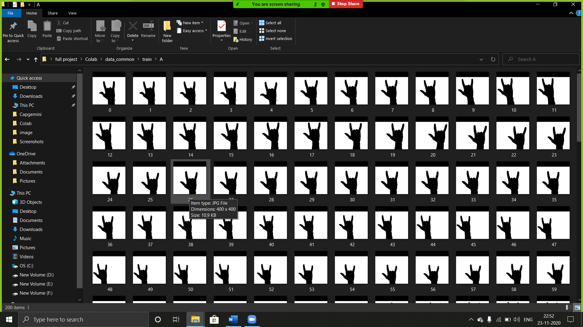

Appendix 6: Dataset of Alphabet(“C”)

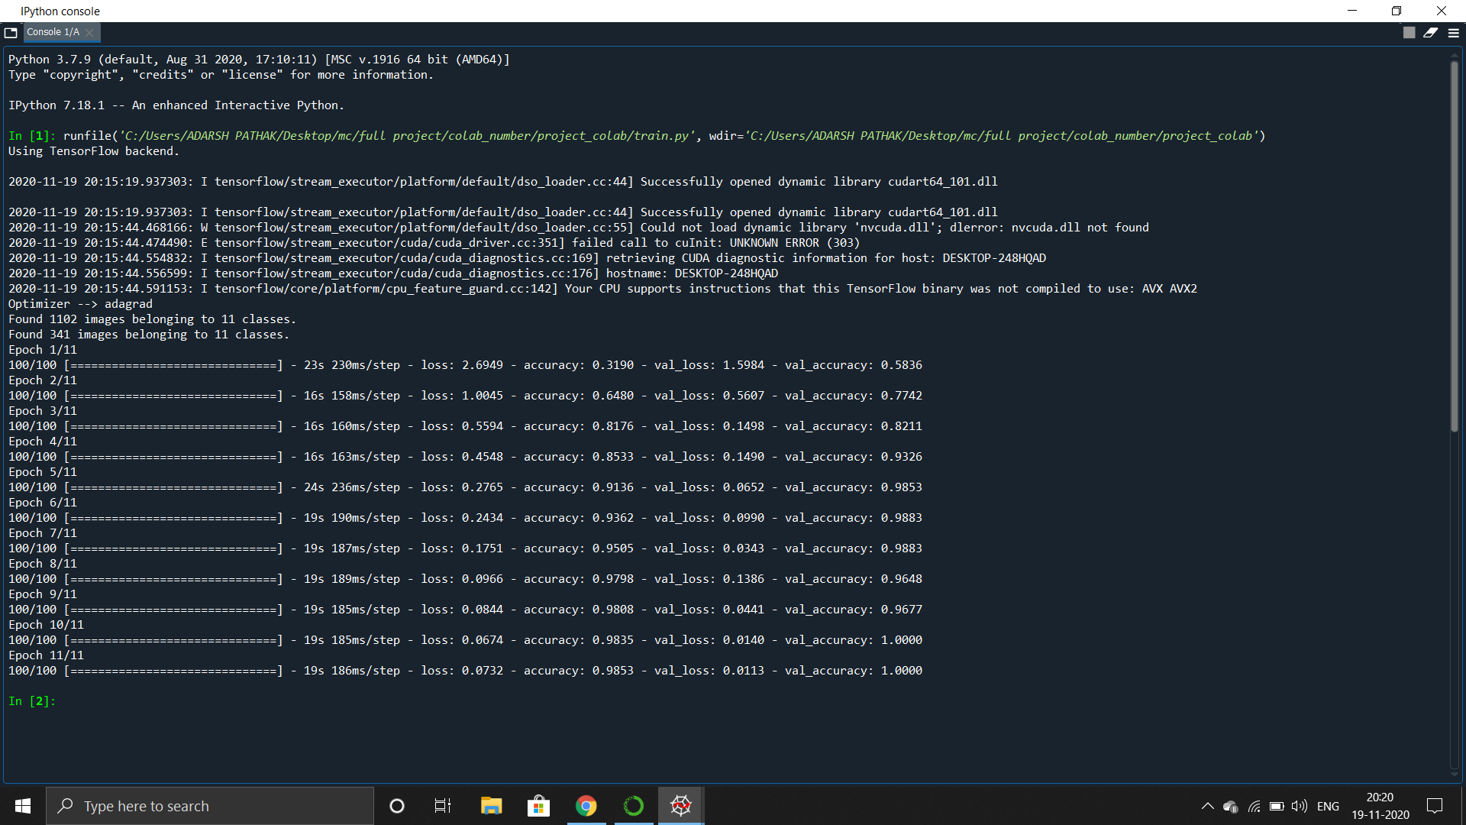 Appendix 7: Training of CNN model(Number 0-9)

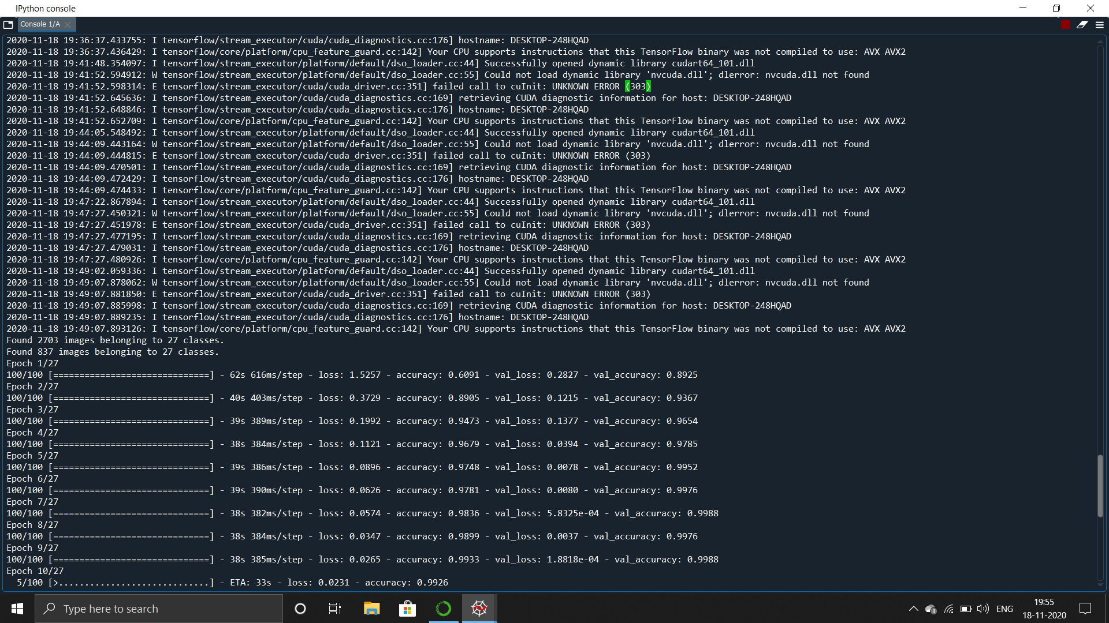

Appendix 8: Training of CNN model(A-Z)

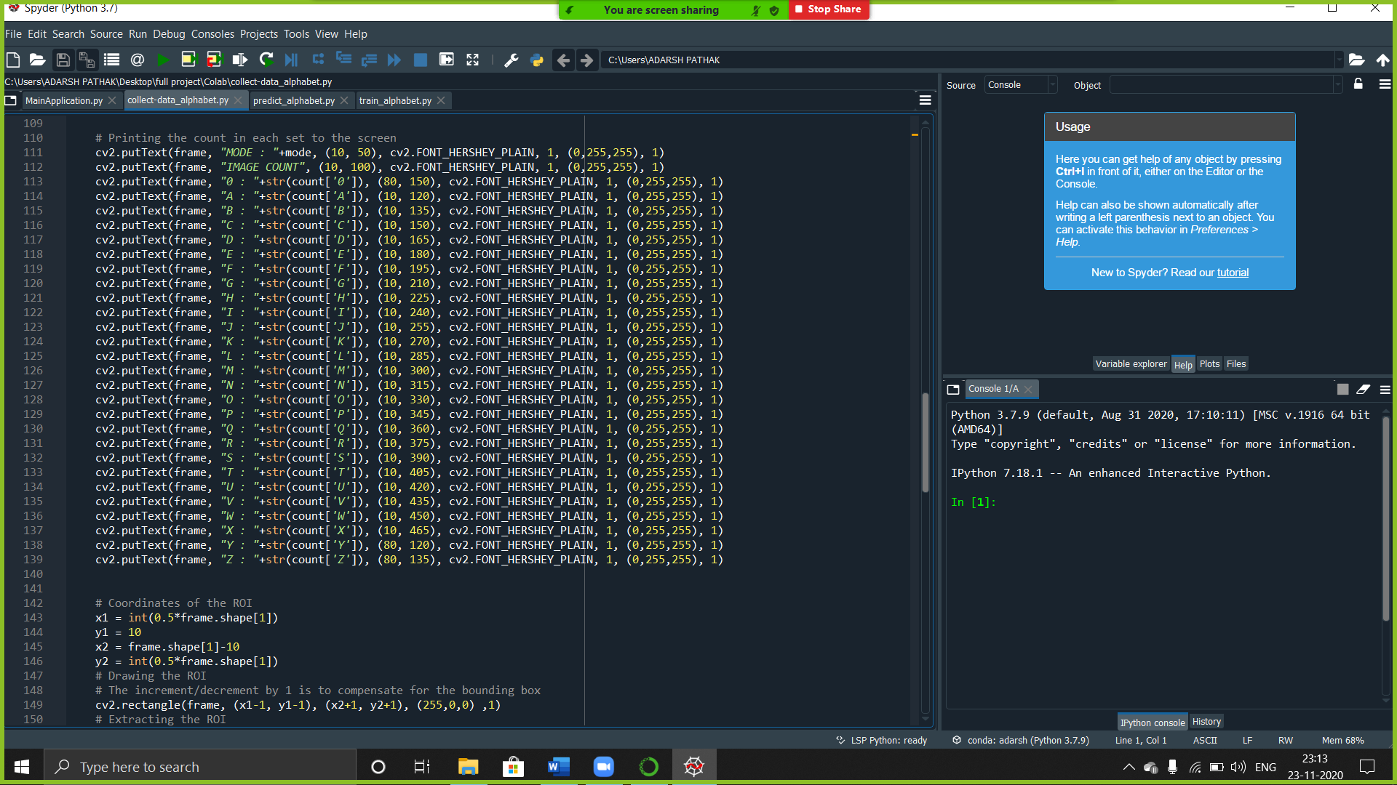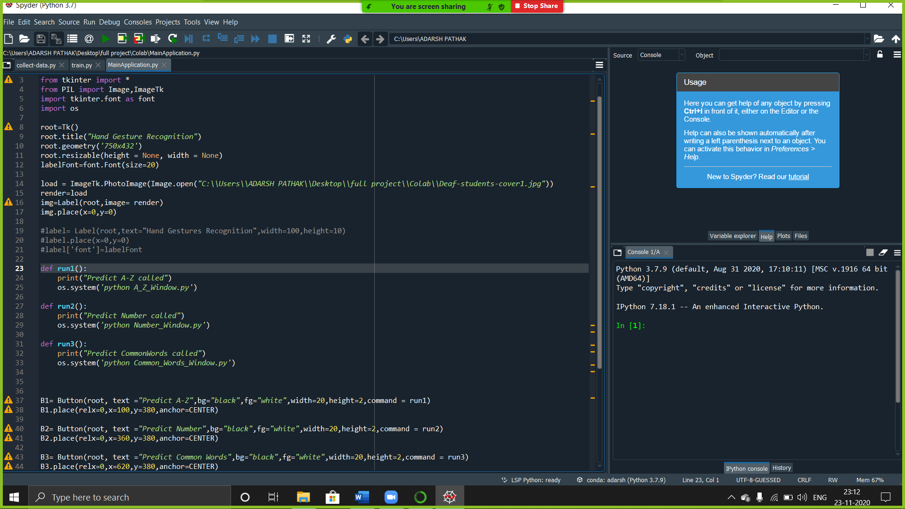 Appendix 9: MainApplication.py

Appendix 10: Collect_number.py

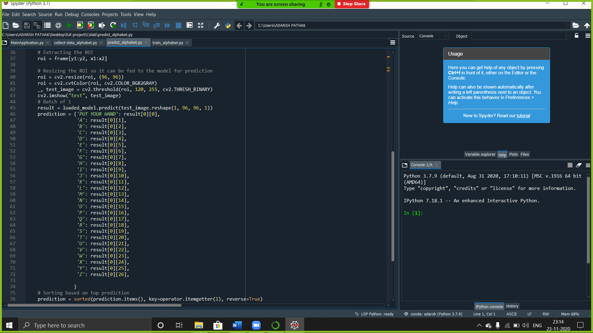 Appendix 11: predict_alohabet.py

LIST OF PUBLICATIONS

[1] Adarsh Pathak, Faraz Ahmed Khan, “*Comparison of CNN and Contour Algorithm for Number Identification Using Hand Gesture Recognition*”, International Conference on Nanotechnology and Smart Materials, Design Artificial Intelligence, Manufacturing and Engineering (ICNSMDAIME-21).